Indoor Driving Obstacles/Cones

2006-2024

Mike Watts and Fiona Powell

ihdtm@mikewatts.com

Contents

- ICD event obstacle diagrams
- ICD World cup style courses
- ICD Cones courses

This is a collection of obstacle, cones and worldcup courses we have used, published here for anyone to use*.

If you use any of these, please let me know how you get on, any new ideas, improvements you have … !
Please send me your own obstacle and cones designs and we can add to the collection for sharing (with your designer name).

Scale: At Wix each obstacle is built in an arena 21m wide and uses half the arena length (i.e 27m).
The diagrams are close to scale, except the start finish is always a little further away – 27m from top.
The nature of the obstacle, how it drives, depends strongly on exactly how you space the elements. Don’t make it too tight.
Legal minimum gate width is 2.5m, but rule of thumb/normal minimum width is 3m. (or 4m from 2023 and larger turnouts)

2021/24 include examples where a cones course is squeezed in around two obstacles. The cones and obstacles are still driven separately, unlike the World Cup style where cones and obstacles are alternated.

See pictures of many of these in use in competitions at www.mikewatts.com

*The safety depends on the materials used [horse friendly] and detailed layout, ground surface, surroundings/environment, turnouts and experience of course builder, drivers, grooms, horses and stewards…..assess the risk, if in doubt, get advice.
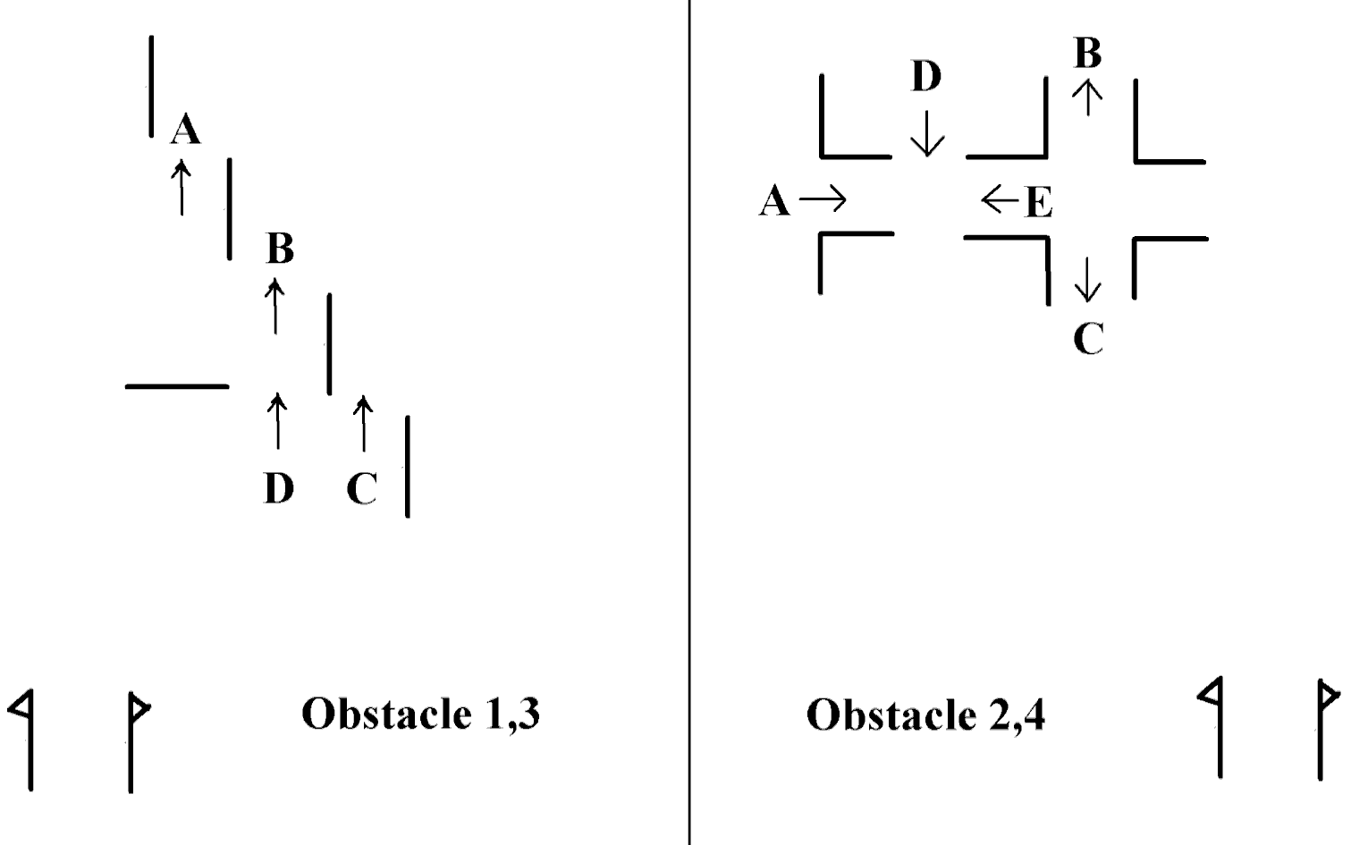
Wix 19 November 2006

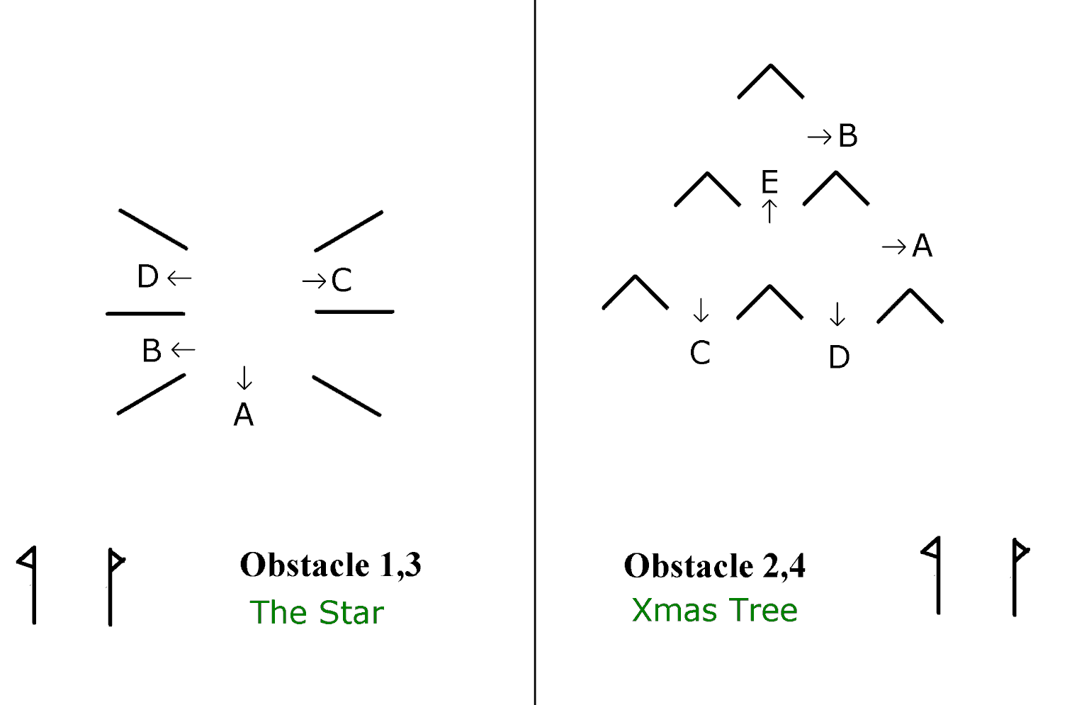
Wix 23rd December 2006
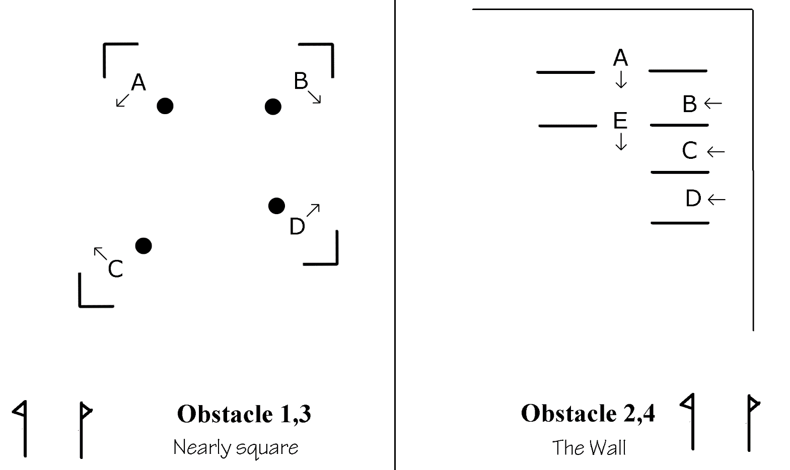

Wix 27 January 2007

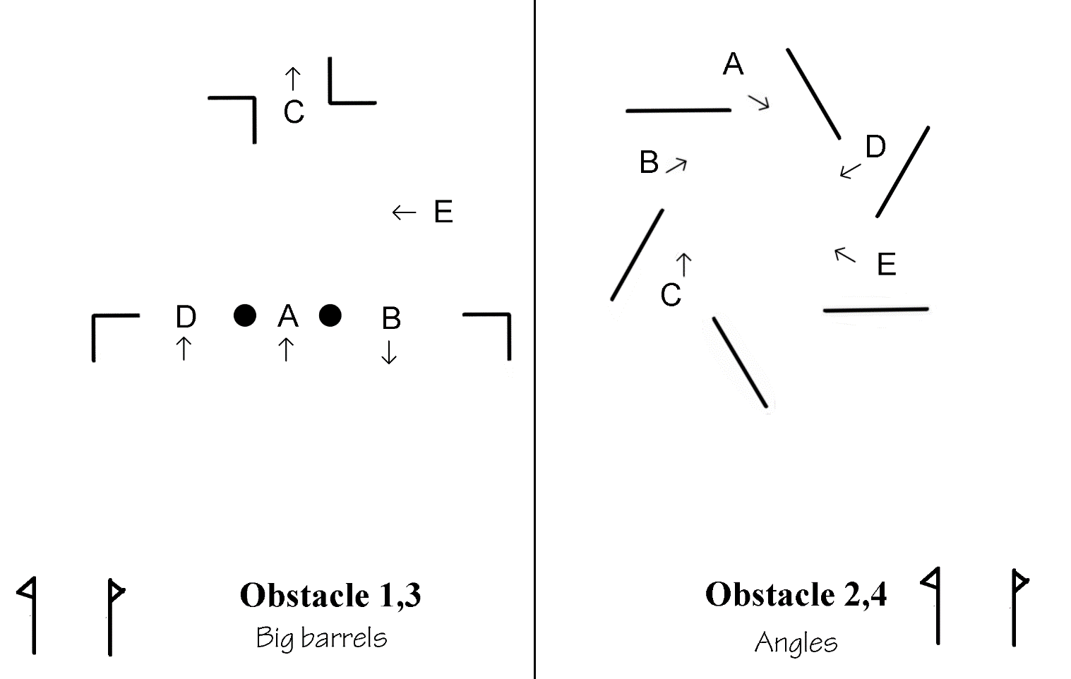

Wix 24 February 2007

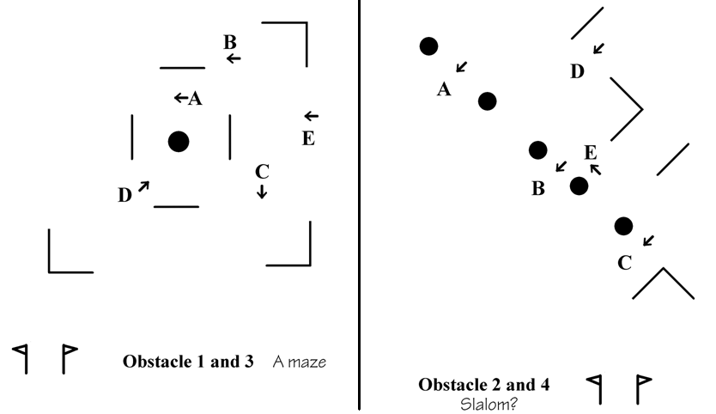

Wix 10th March 2007

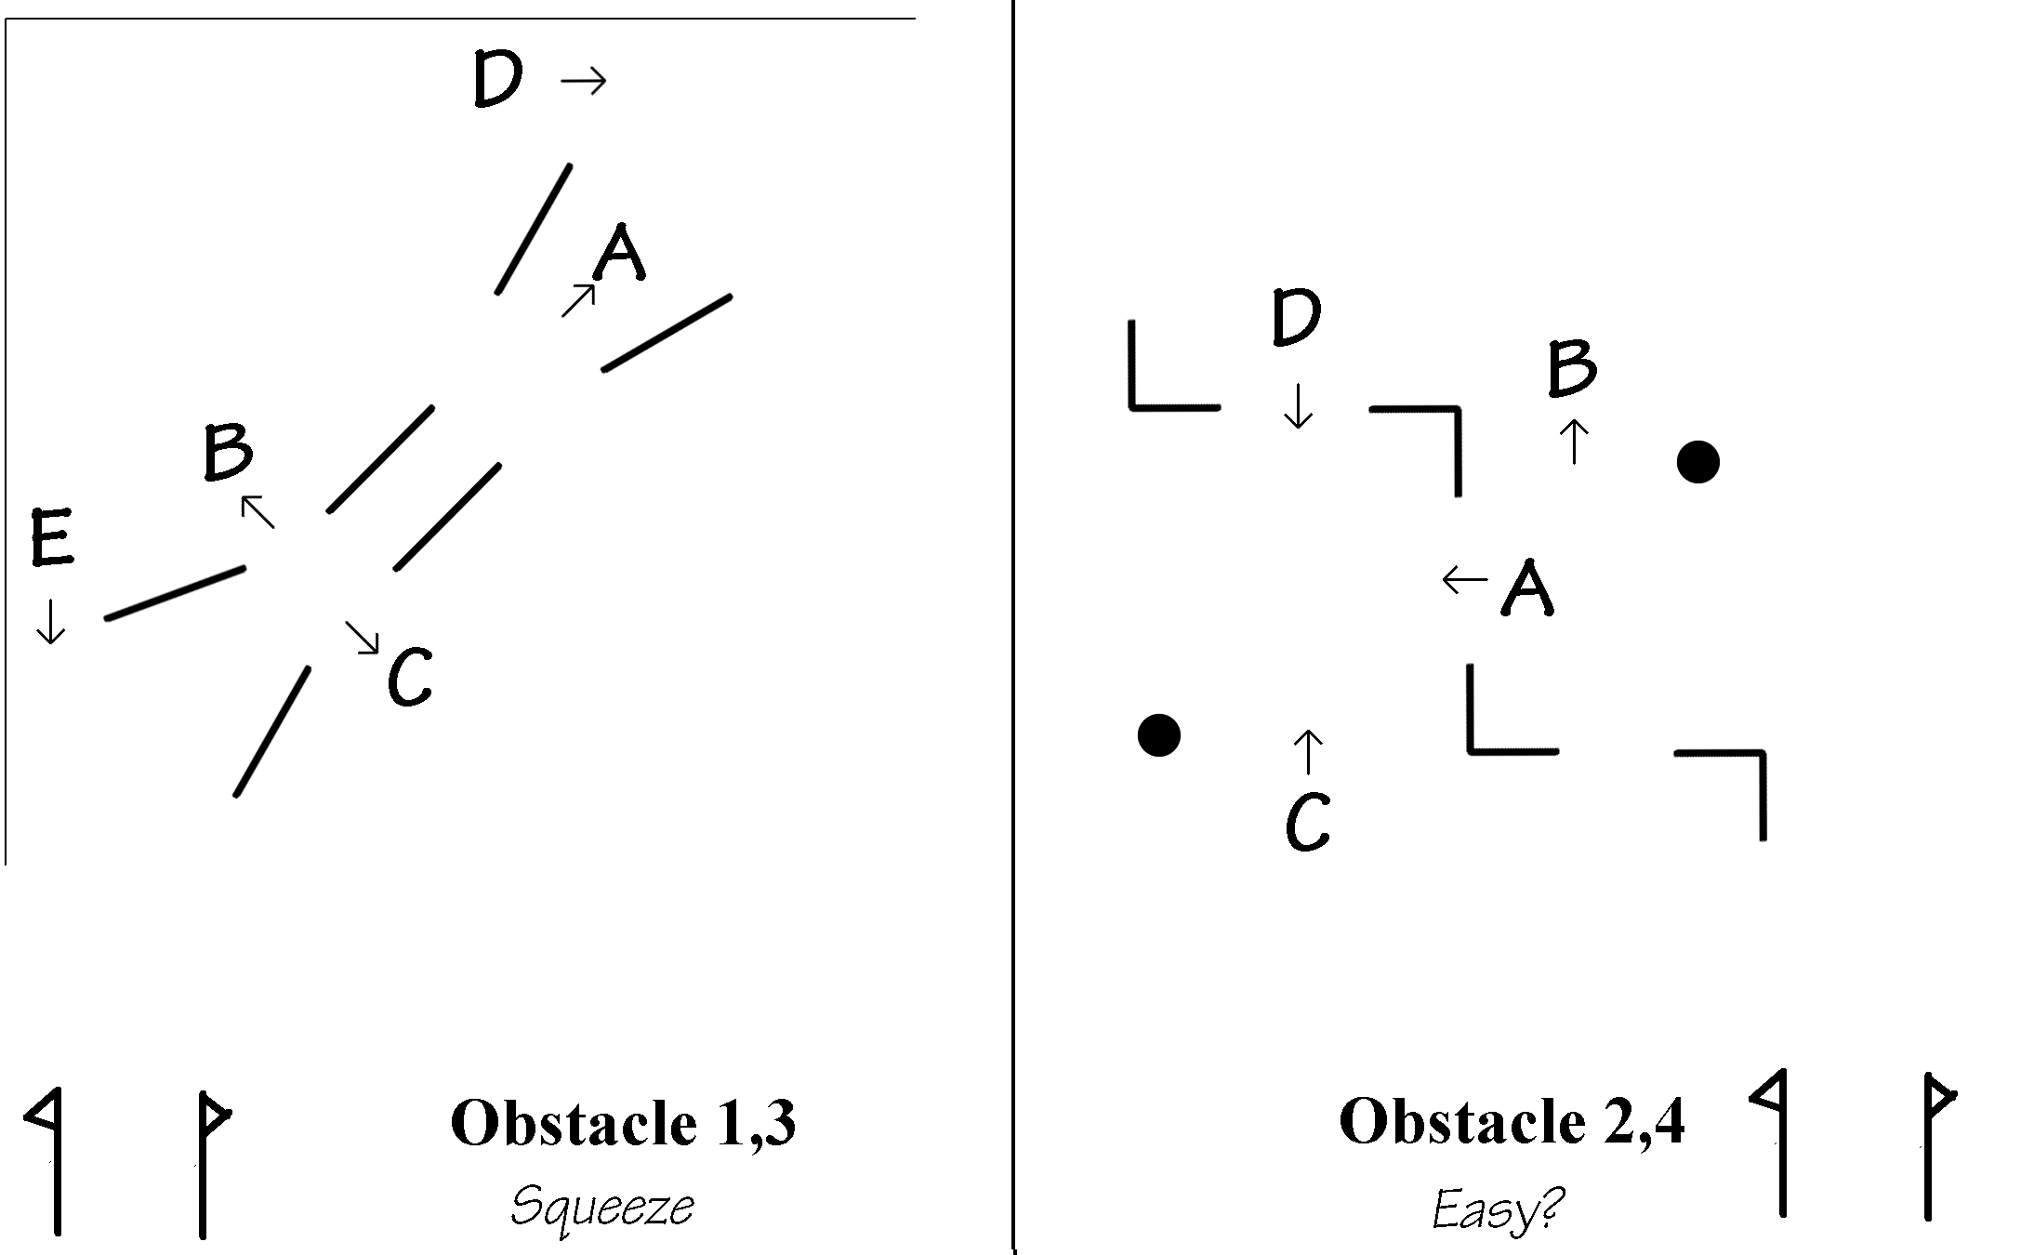
Wix 18 November 2007
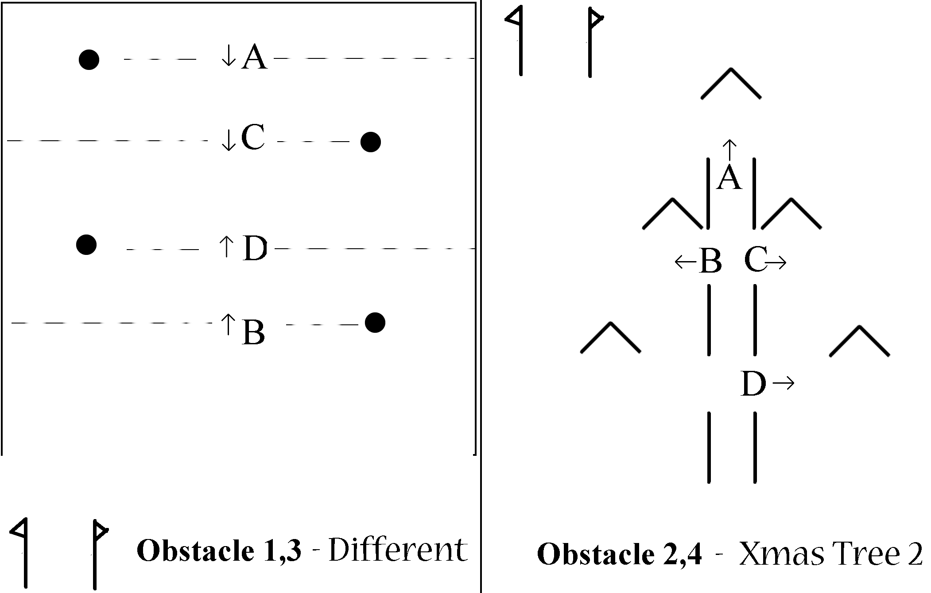

Wix 30 December 2007

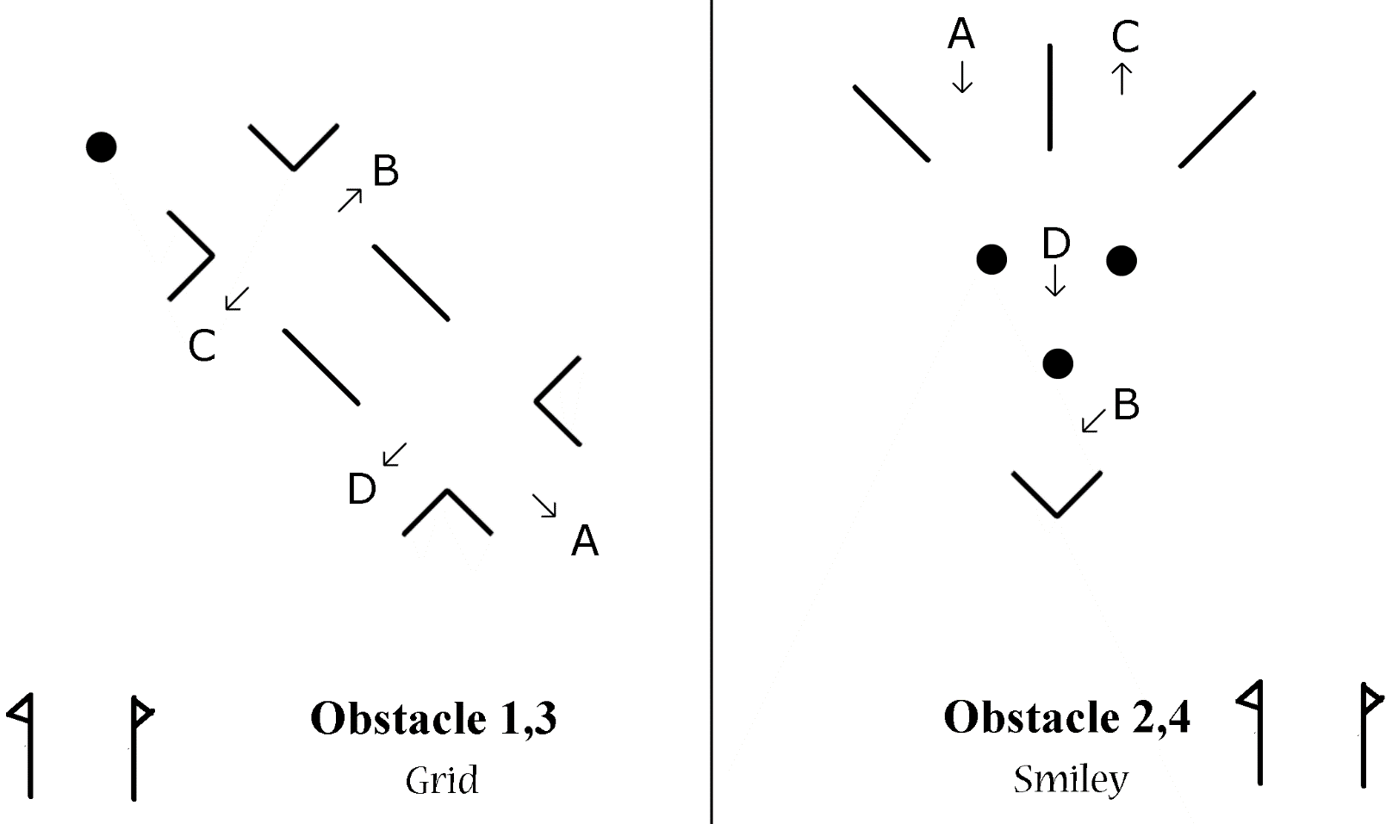
Wix 26th January 2008
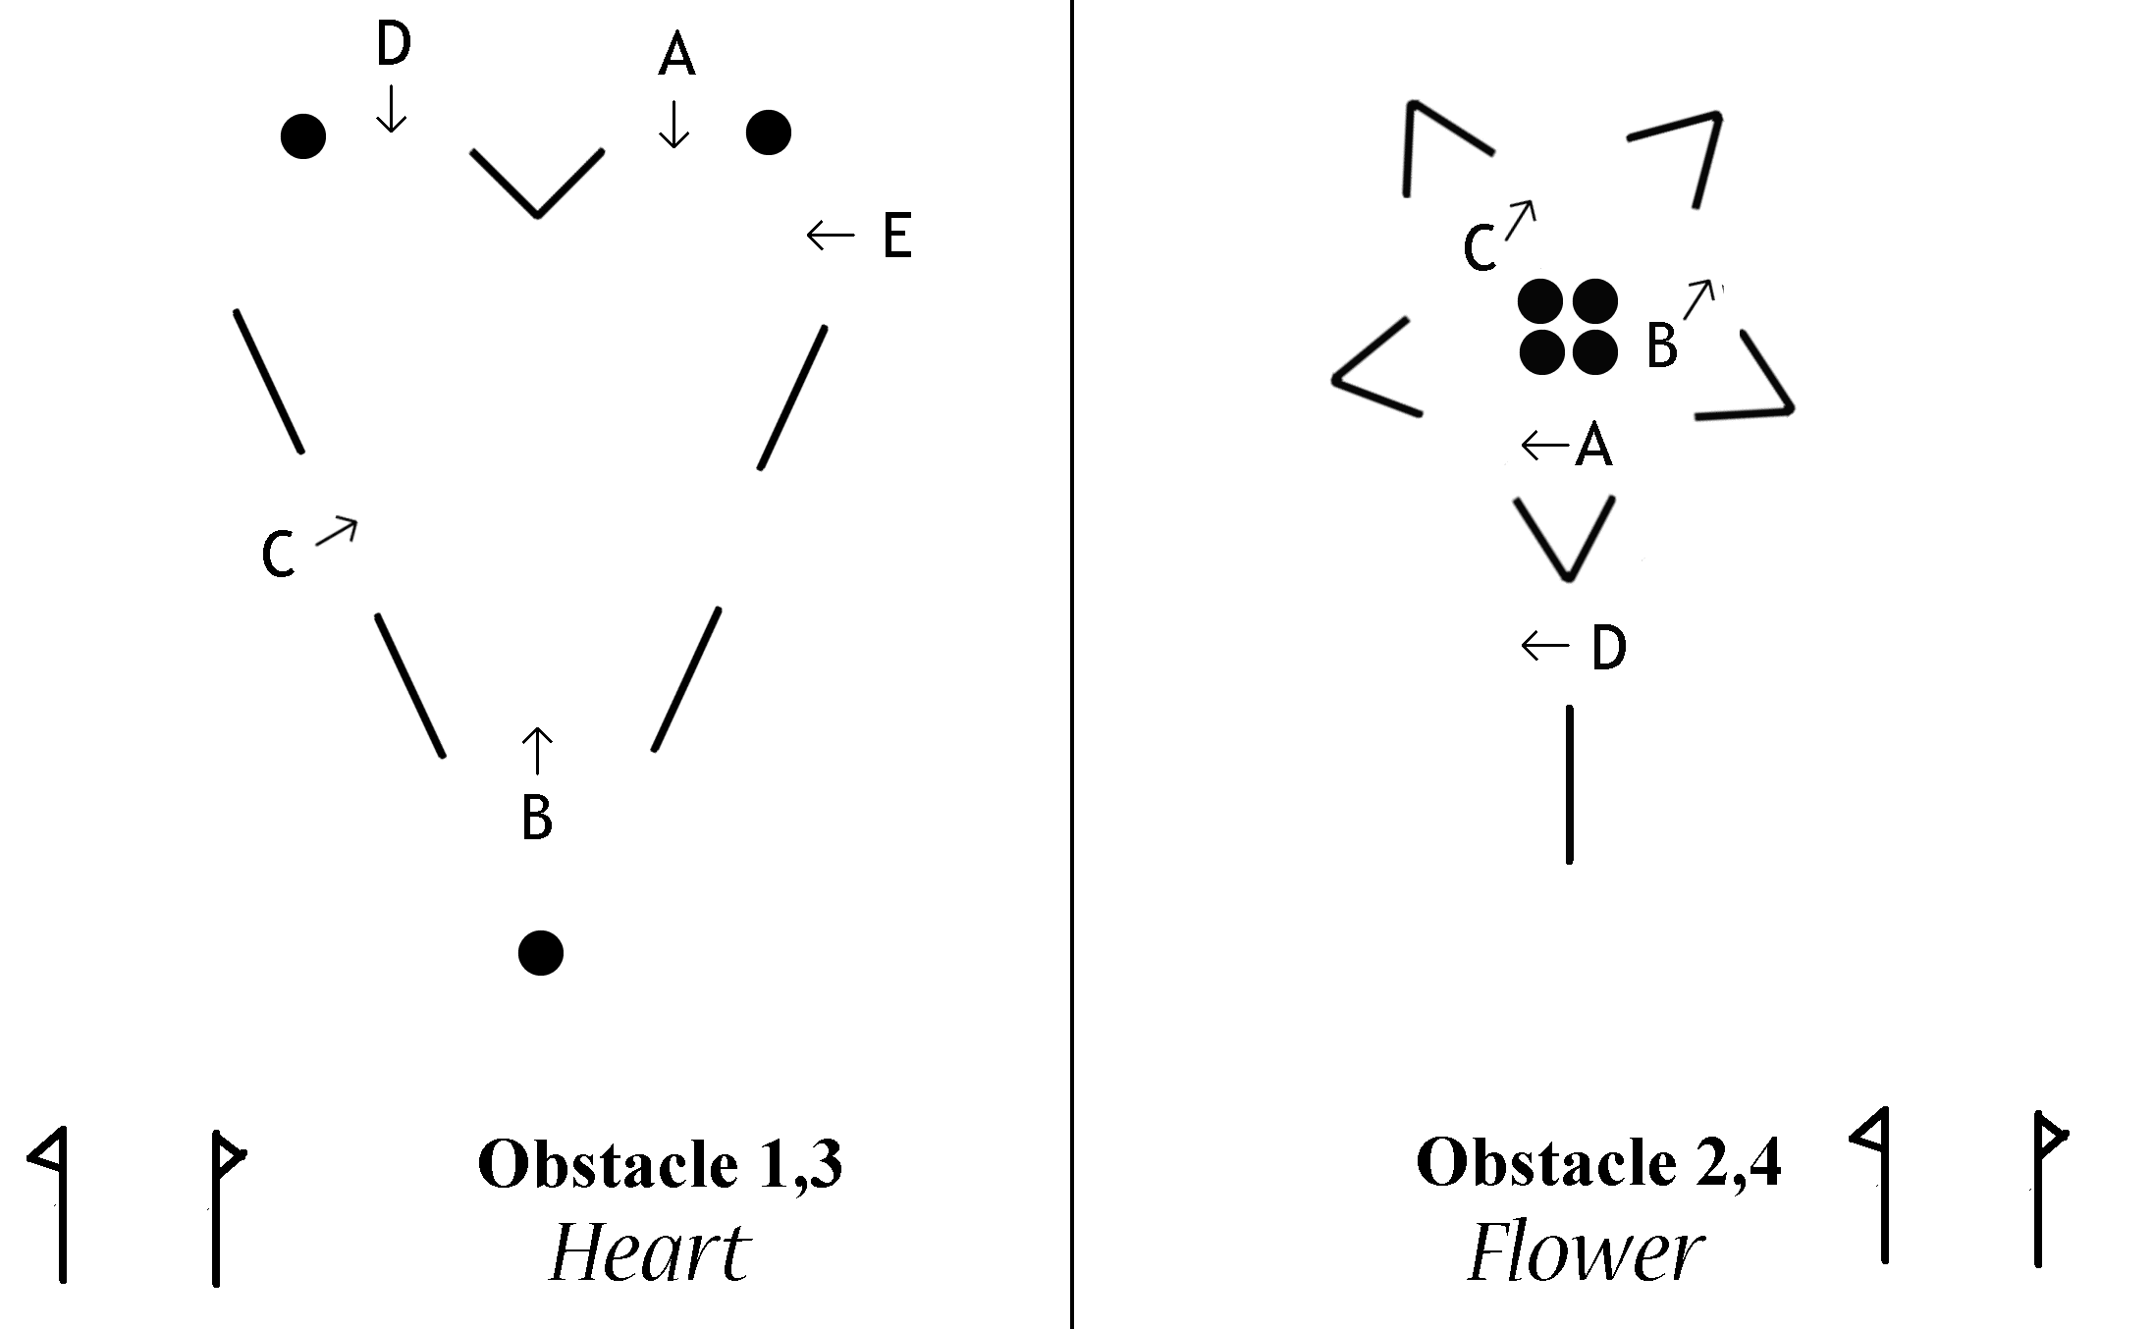
Wix 23 February 2008

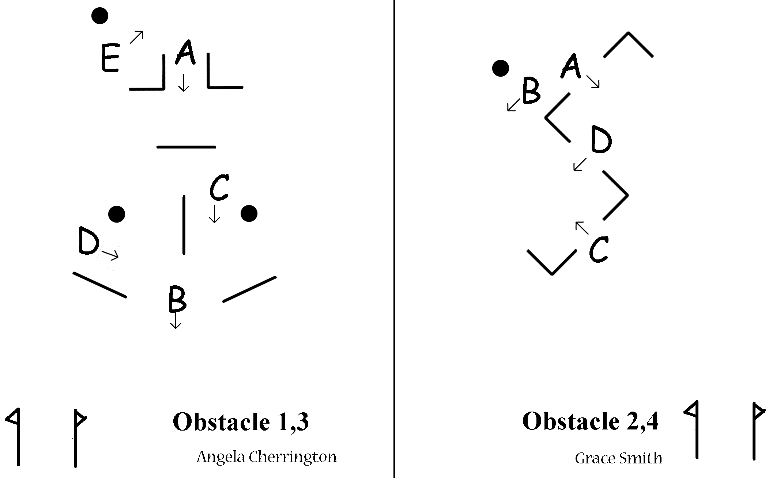
Wix 8 March 2008
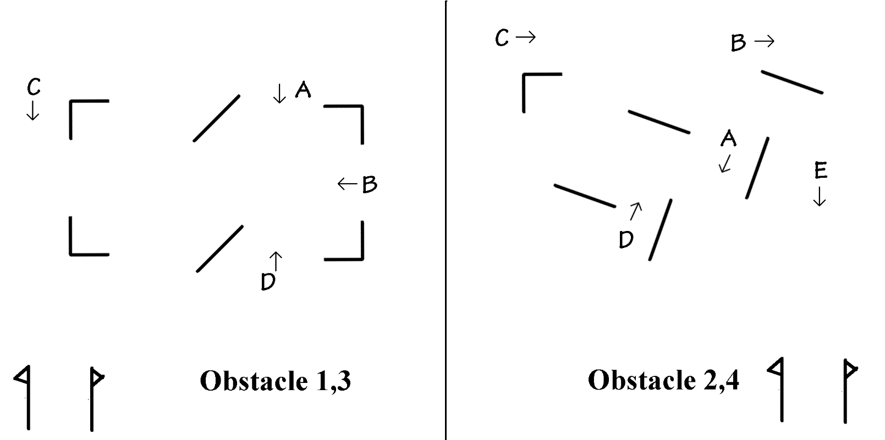

Wix 30 November 2008

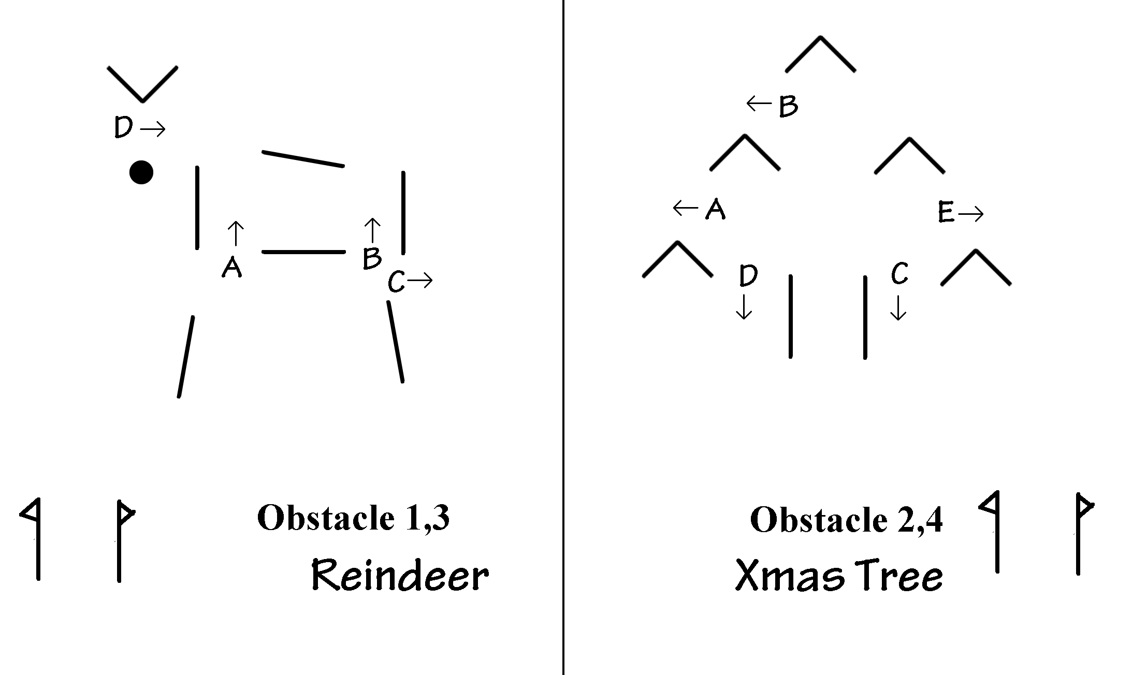
Wix 3 Jan 2009

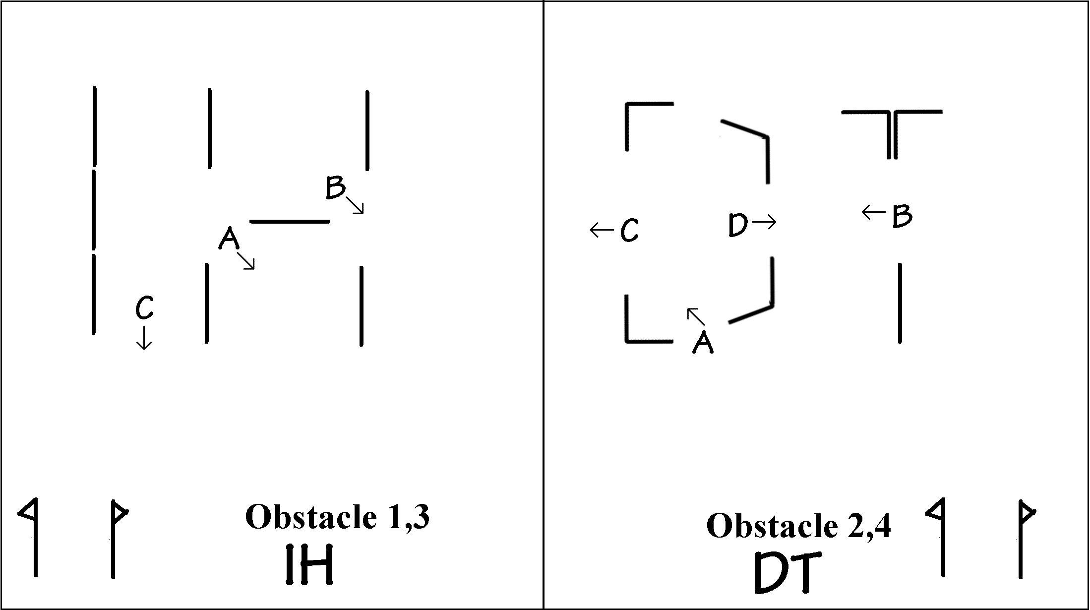

Wix 31 Jan 2009

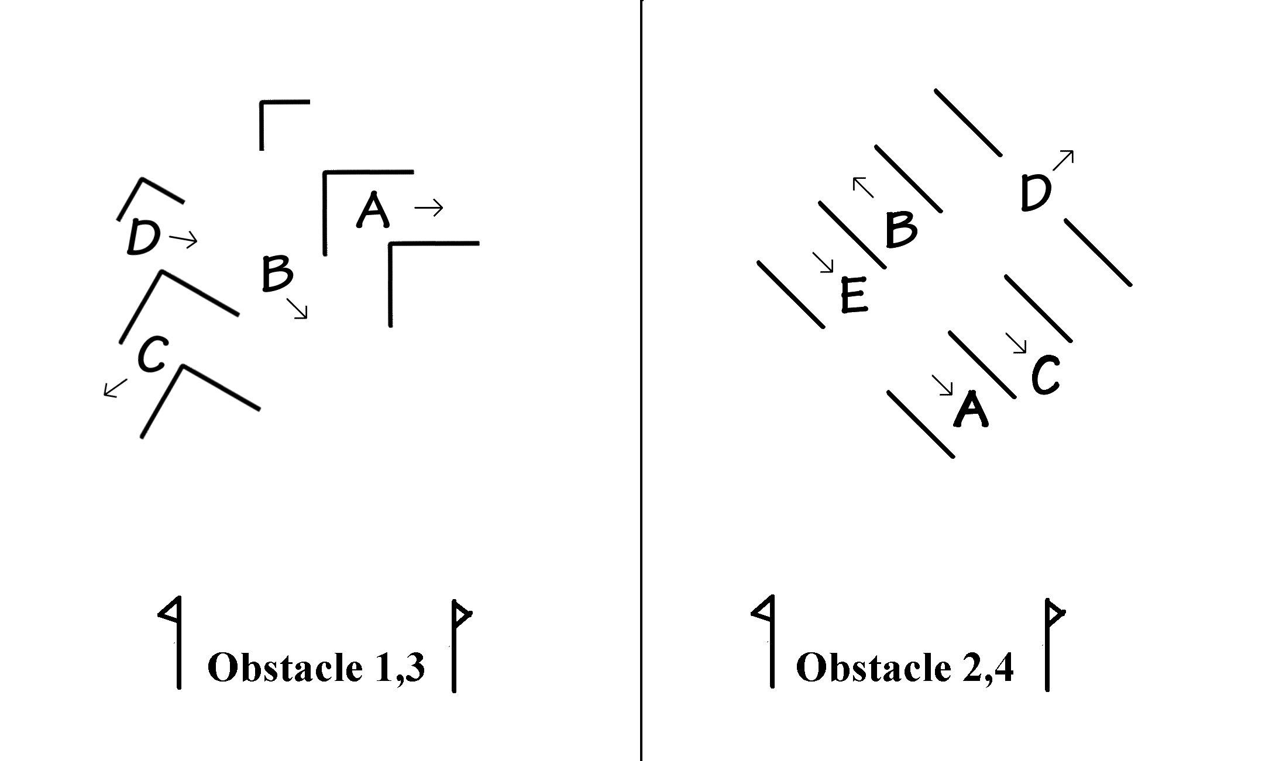

Wix 28 Feb 2009 (Barbara Nadin)
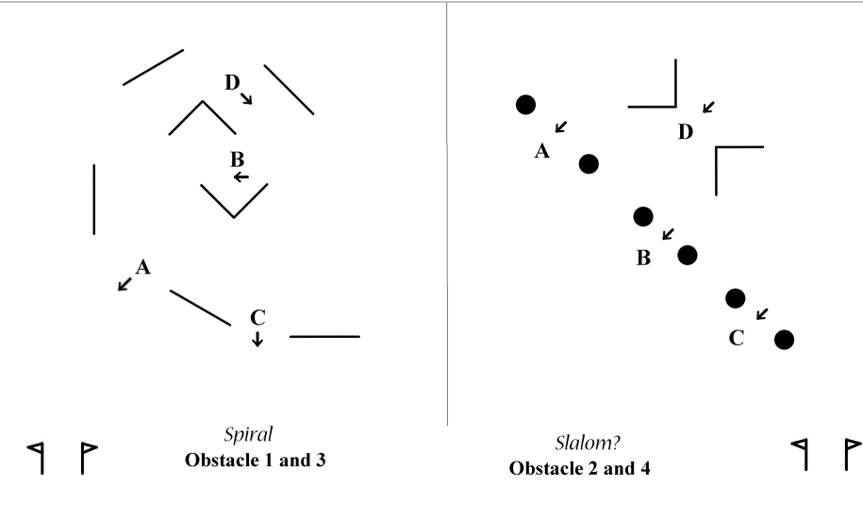
Wix 14 March 2009

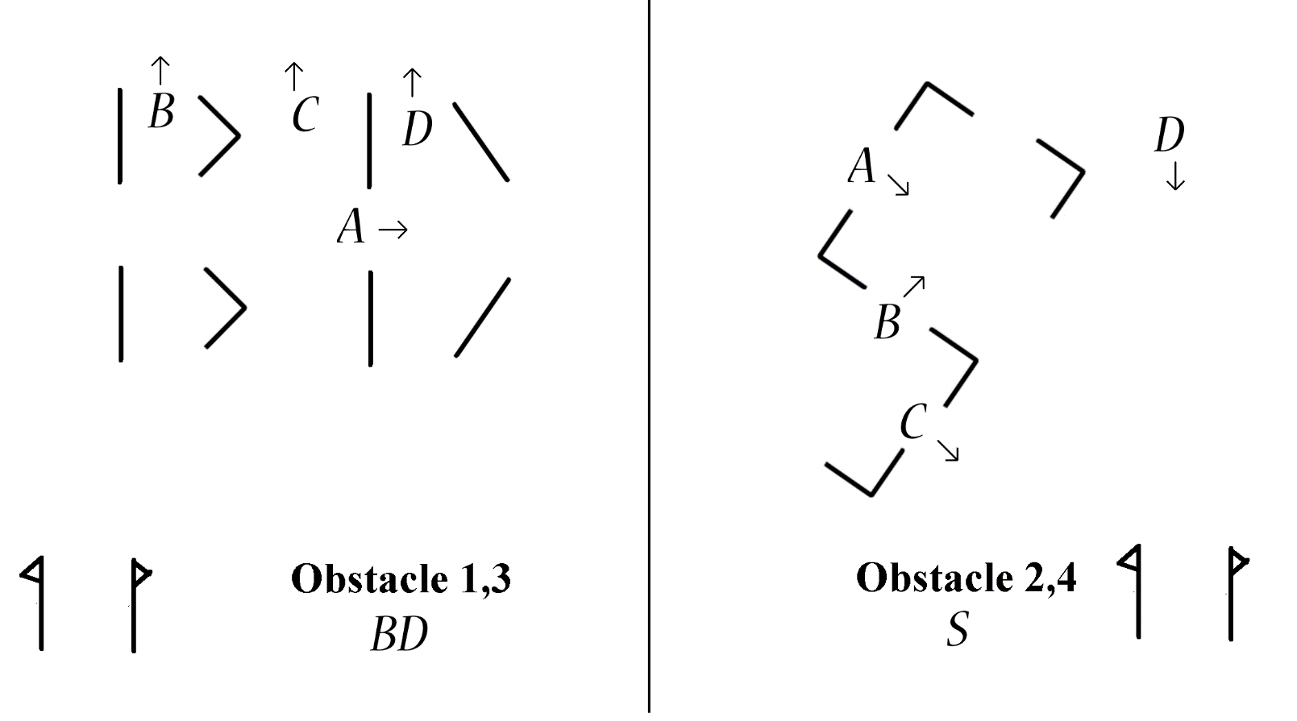

Humberstone 21 March 2009

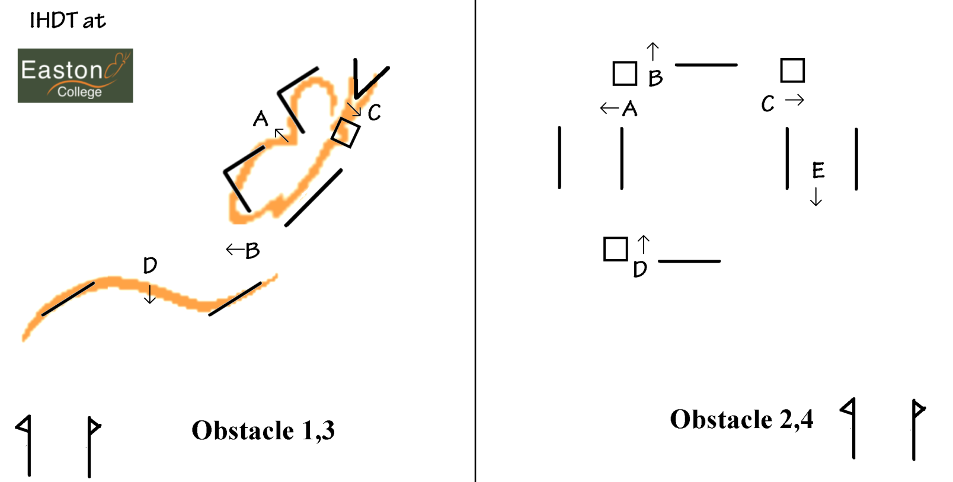
Easton 15 November 2009

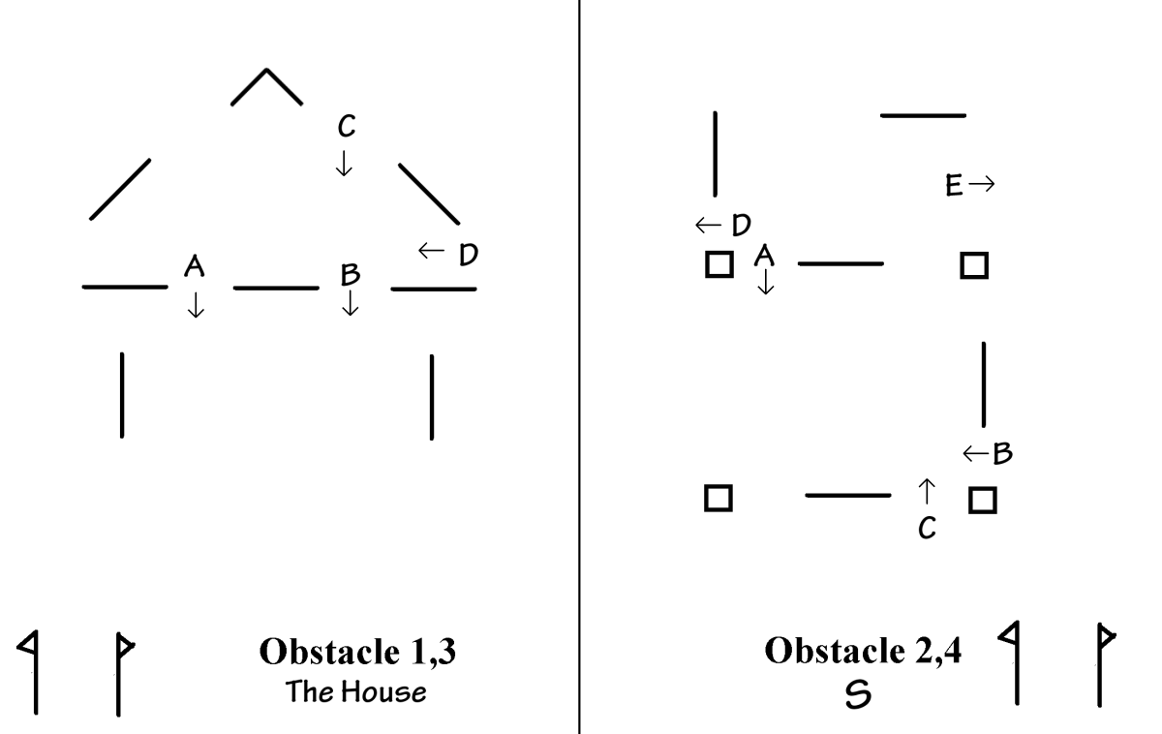

Wix 29 November 2009

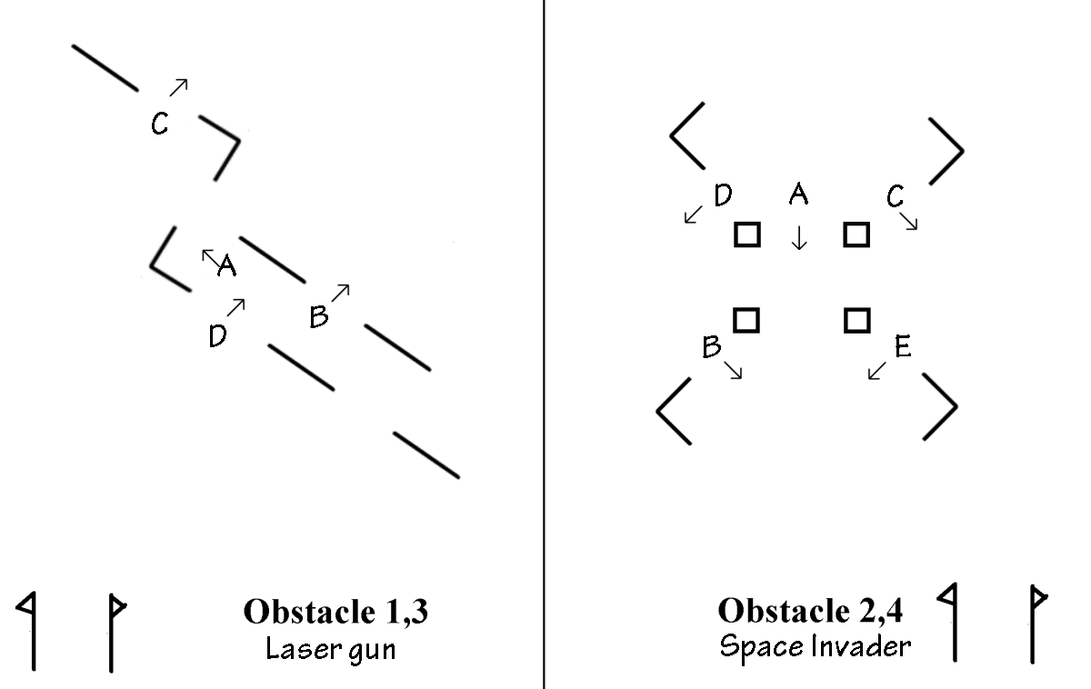

Wix 30th January 2010

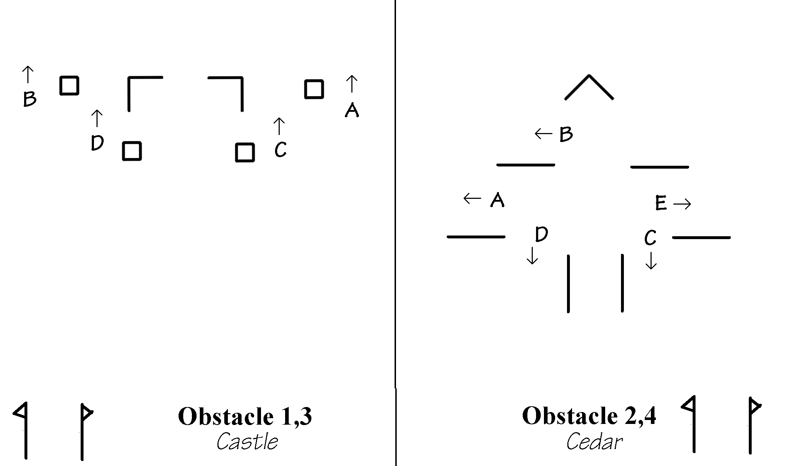

Wix 21 Feb 2010

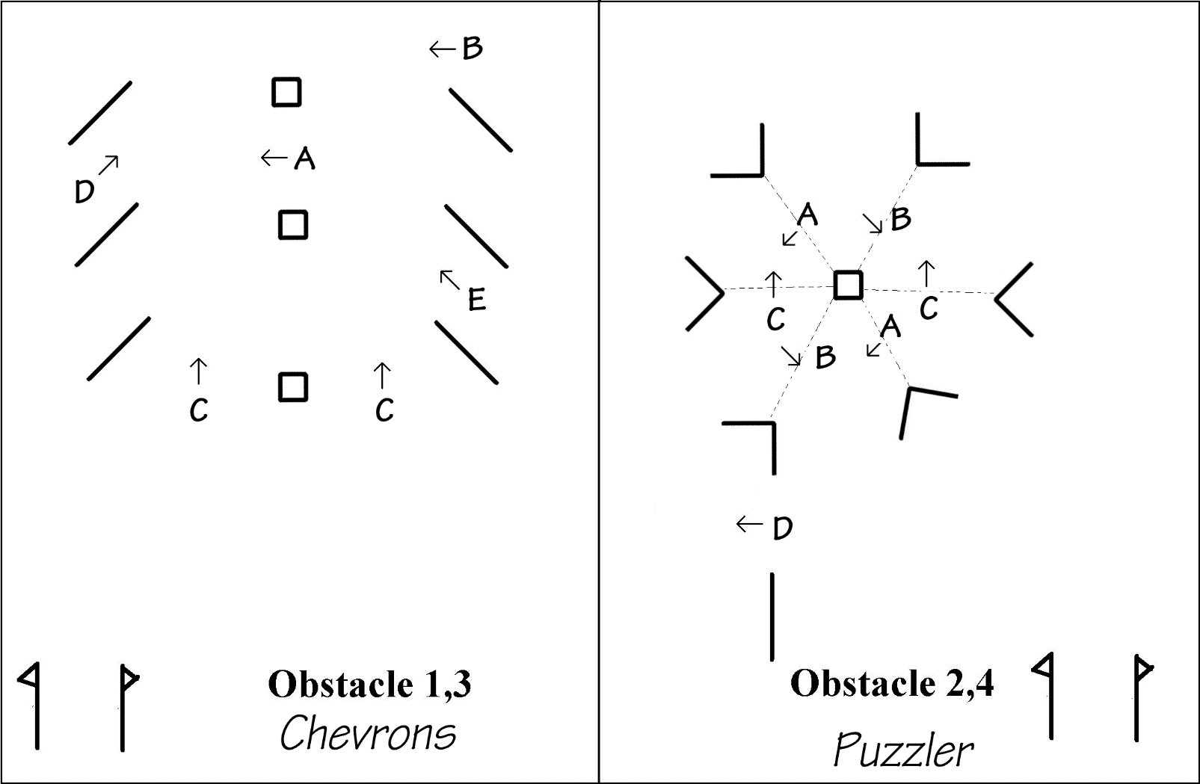

Wix 13 Mar 2010
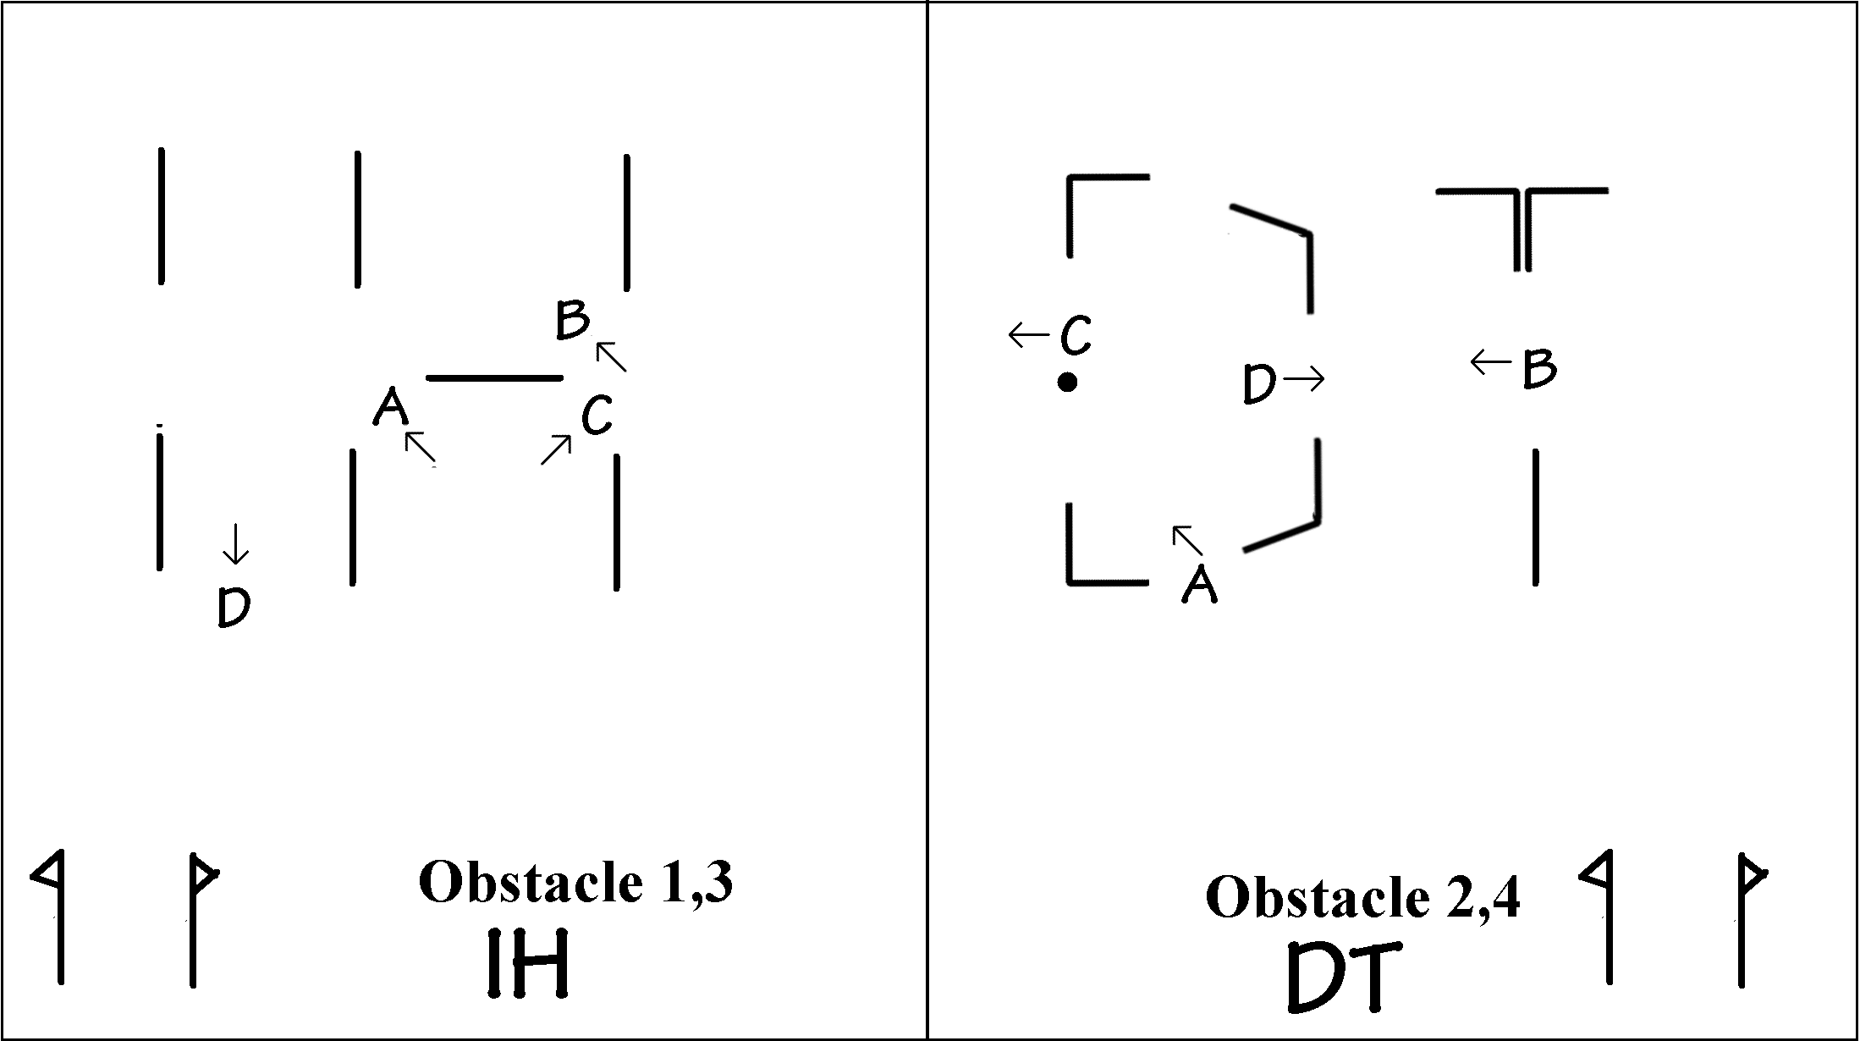

Wix 24 Oct 2010

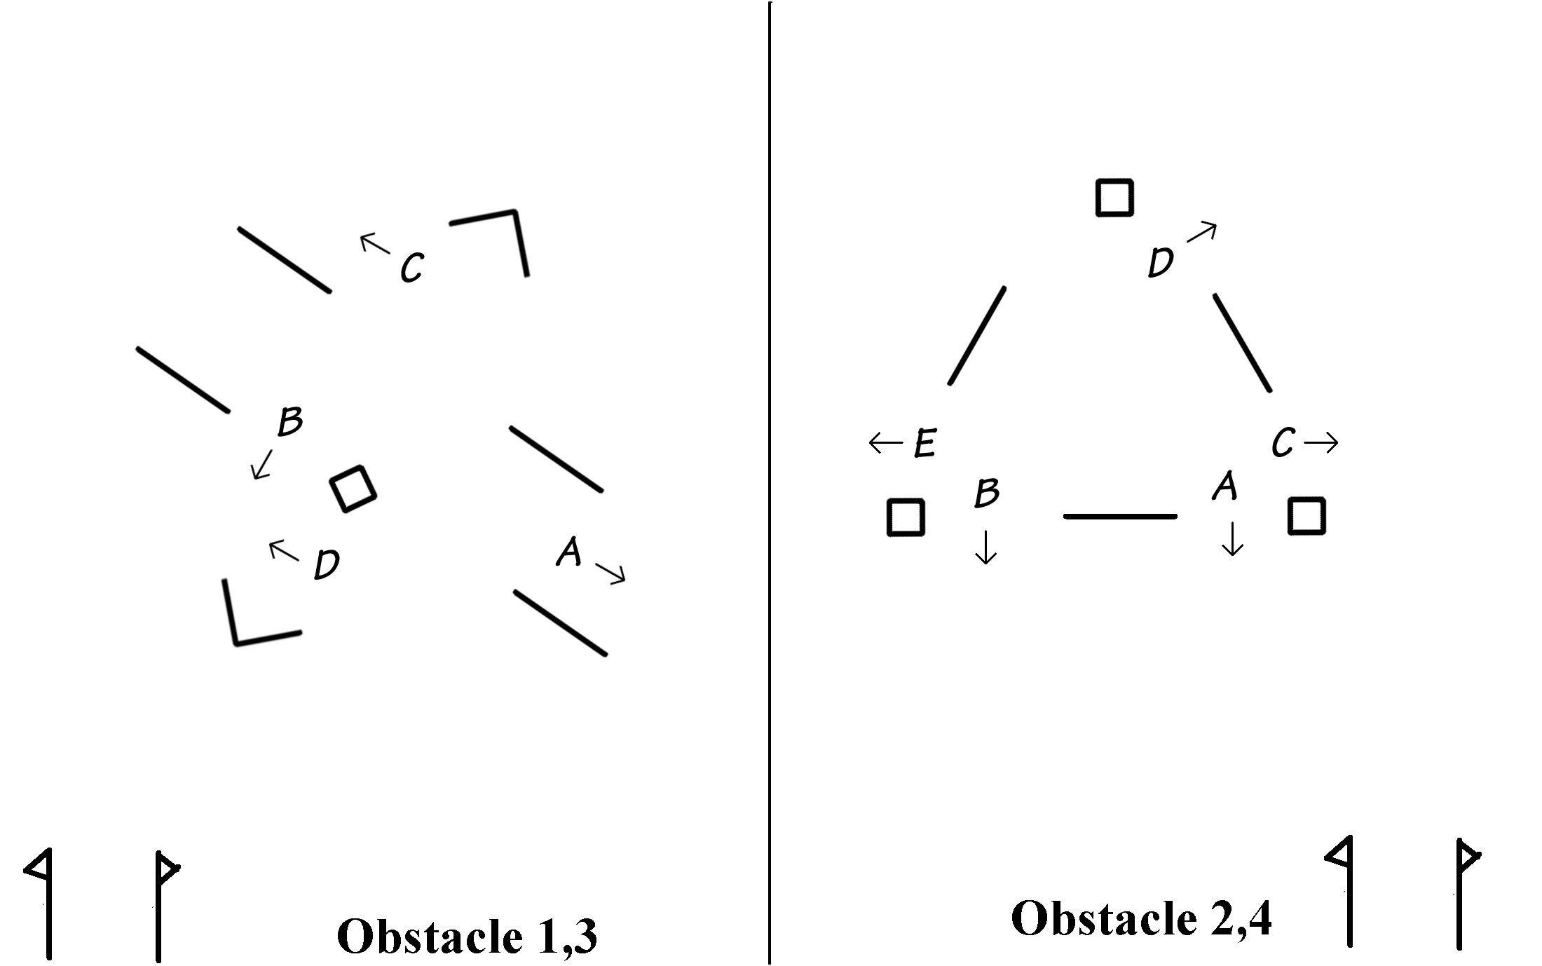

Wix 29 Jan 2011

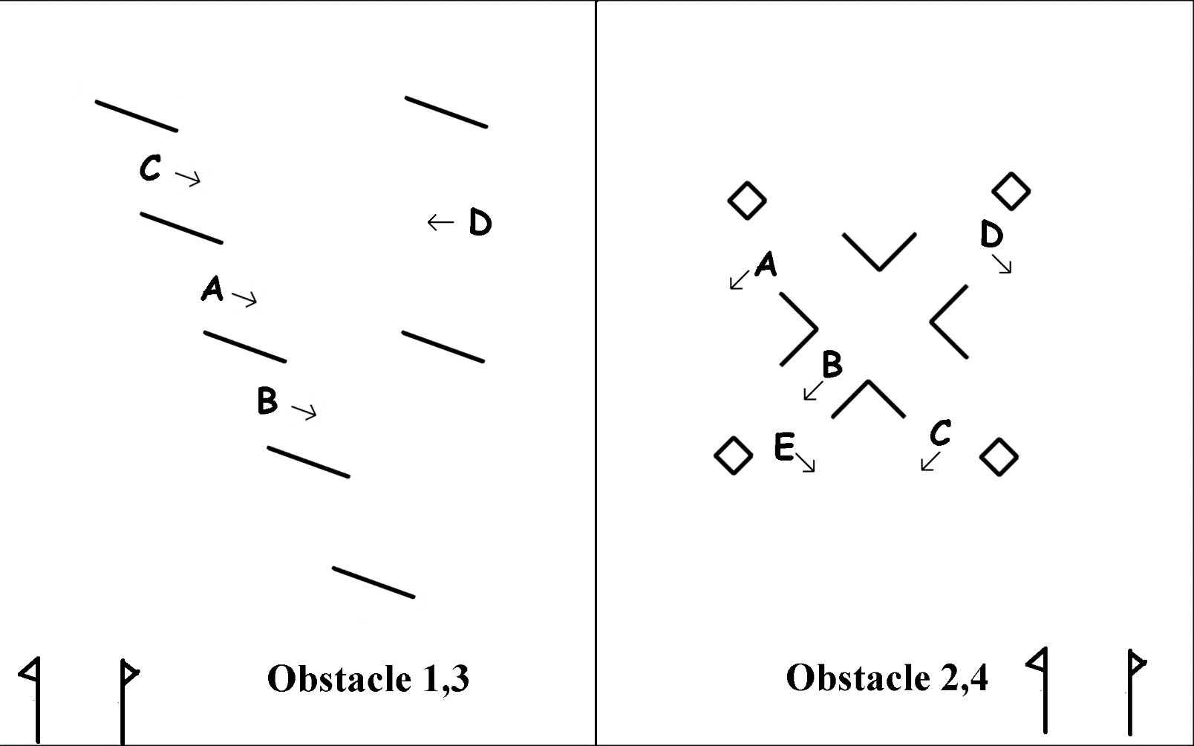

Wix 20 Feb 2011

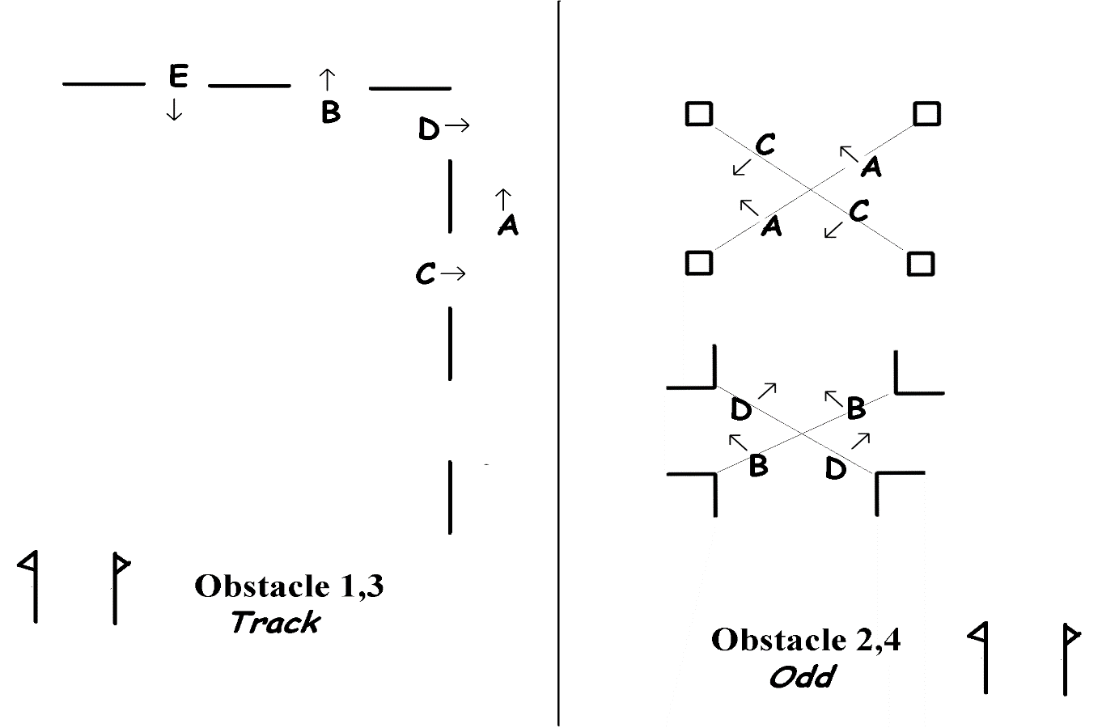

Wix 12 March 2011

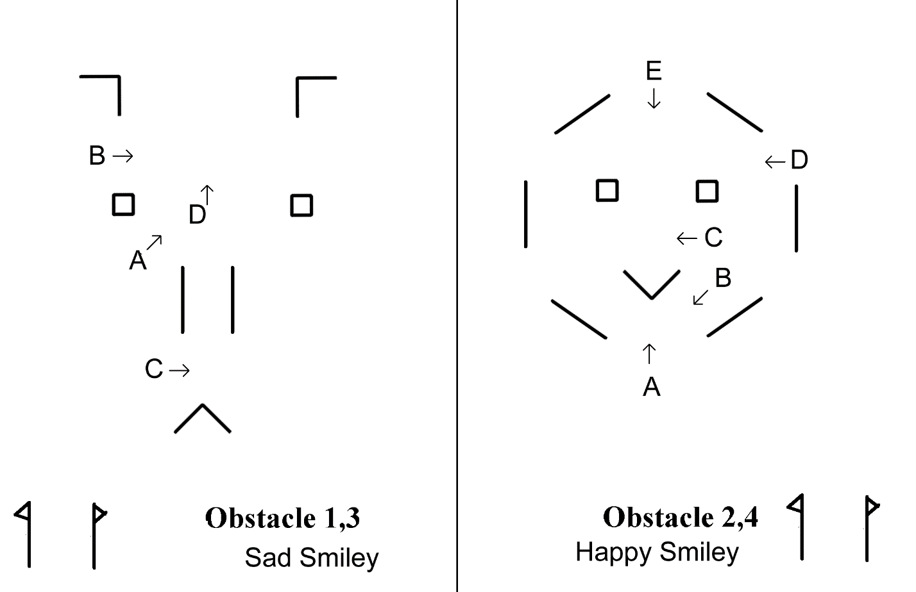

Wix 22 Oct 2011

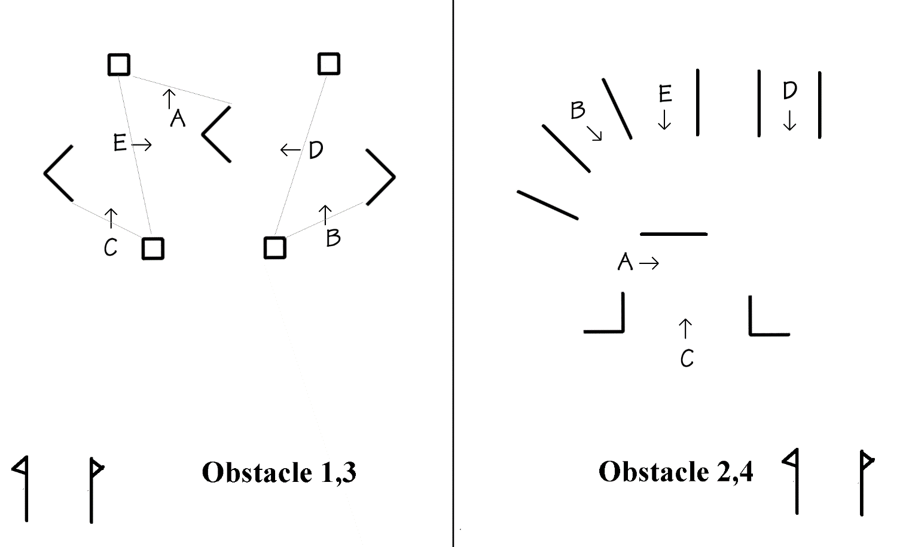

Wix 11 Dec 2011
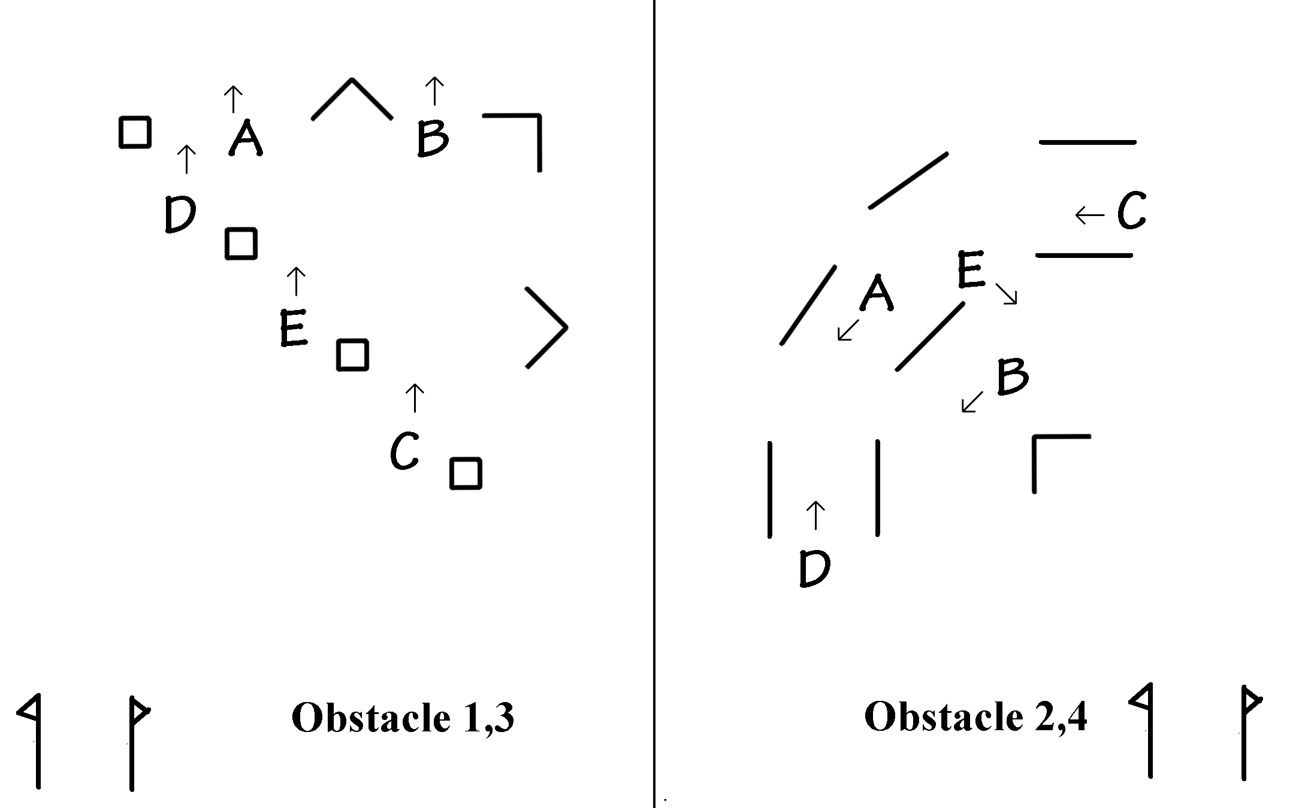

Wix 27 Jan 2012

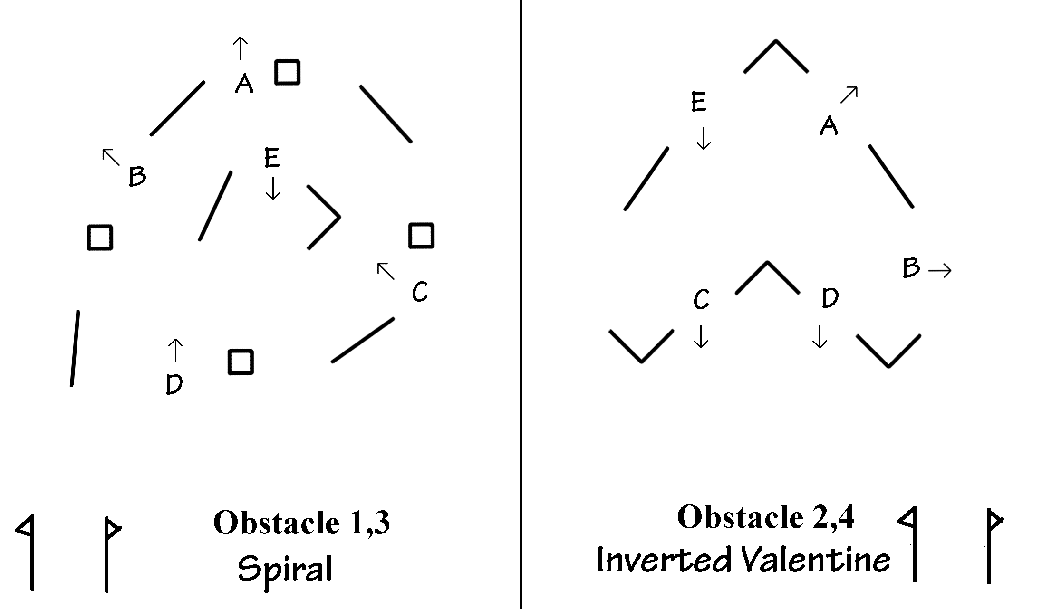Wix 19 Feb 2012
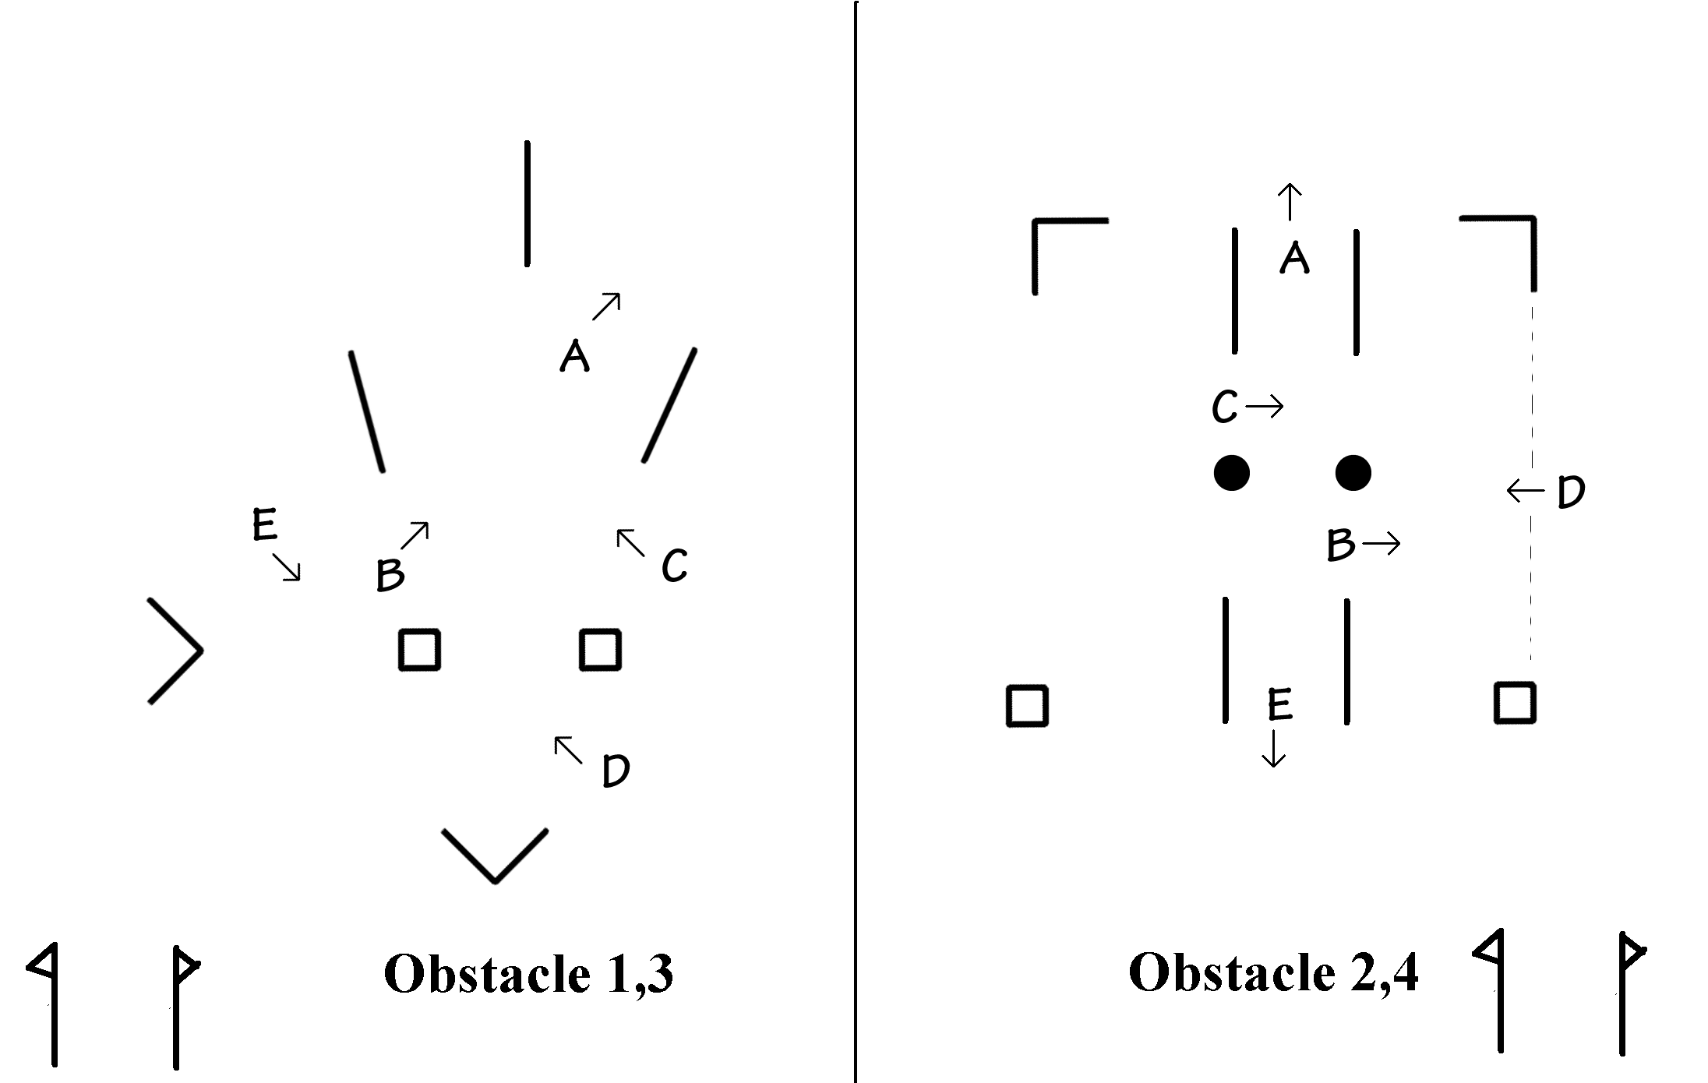Wix 10 March 2012

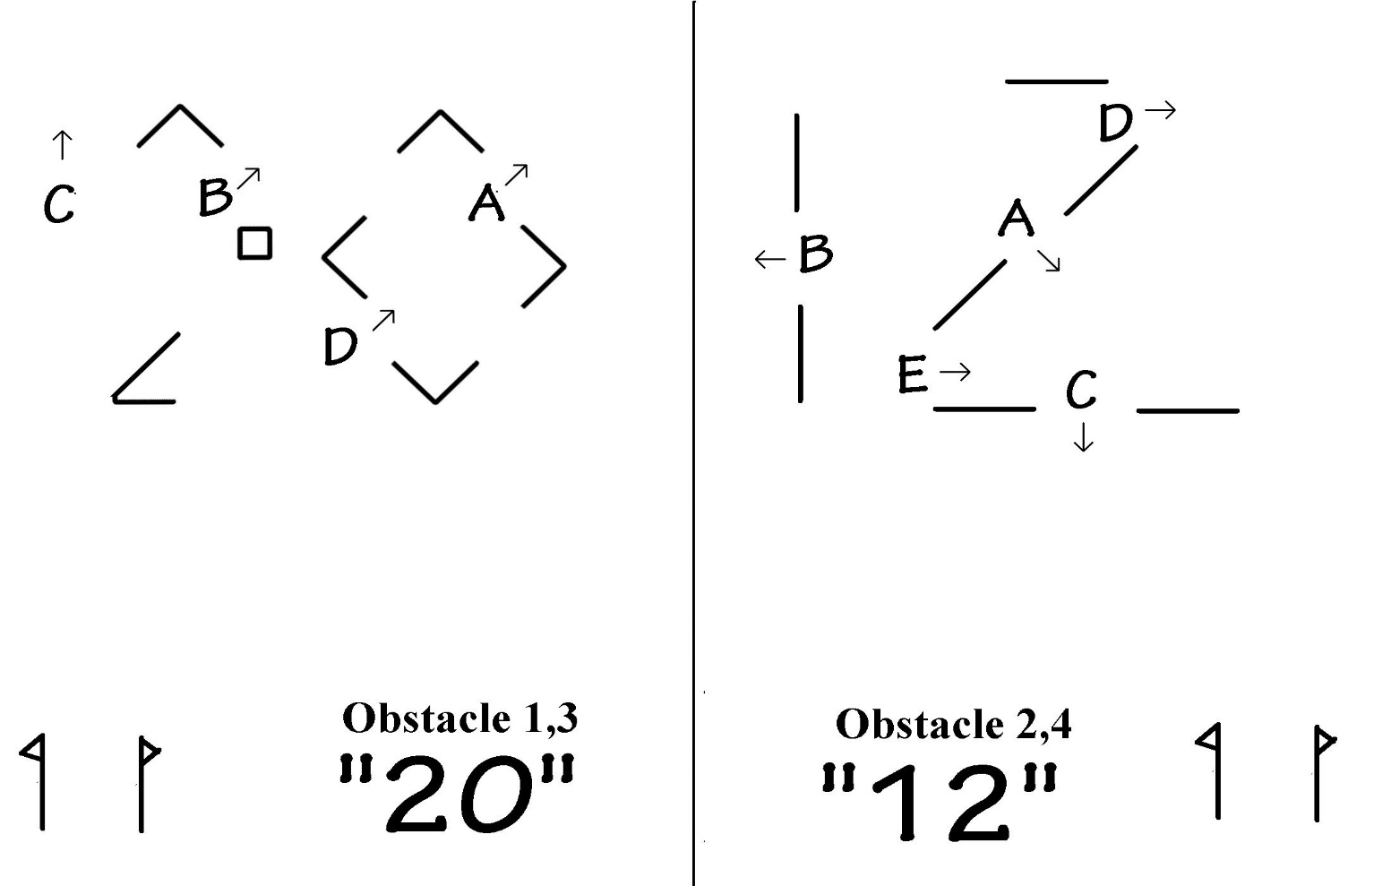
Wix 29 October 2012
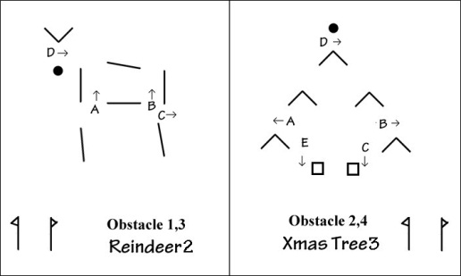
Wix 9 December 2012

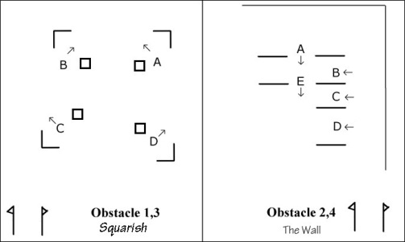
Wix 16 February 2013
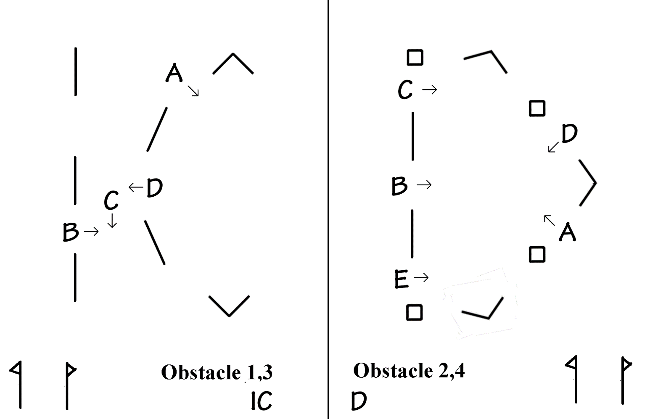
Wix 26 Oct 2013 “ICD”

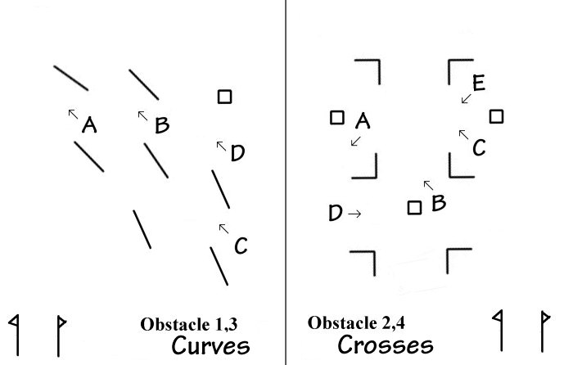
Wix 23 Nov 2013 “Curves and crosses”
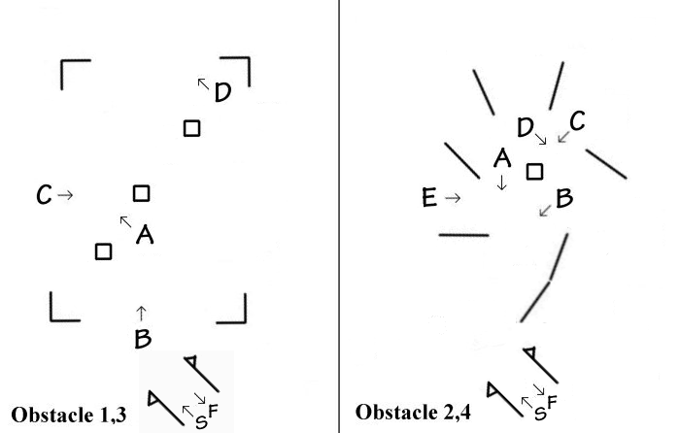
Wix 18 Jan 2014

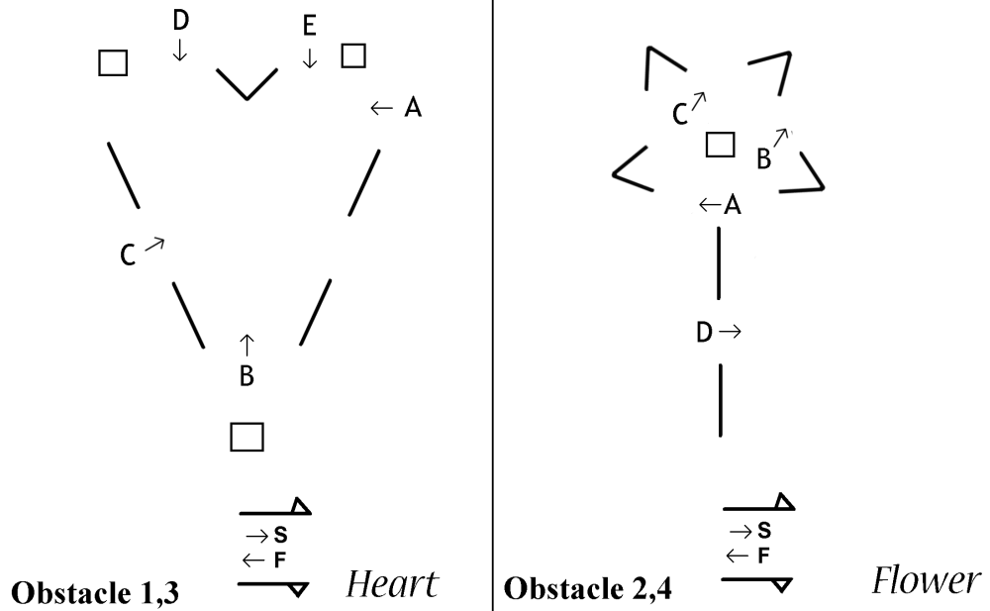

Wix 16 Feb 2014
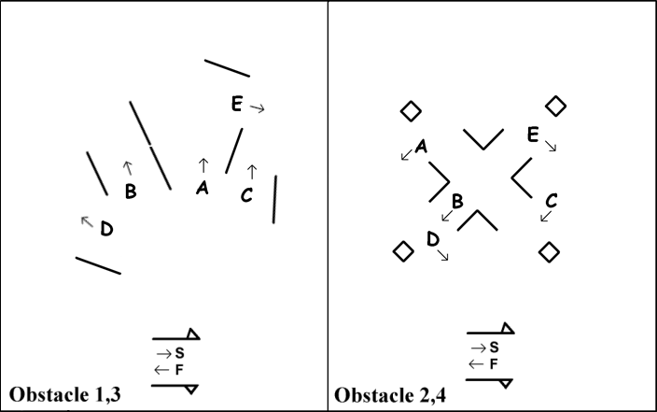

Wix 8th March 2014

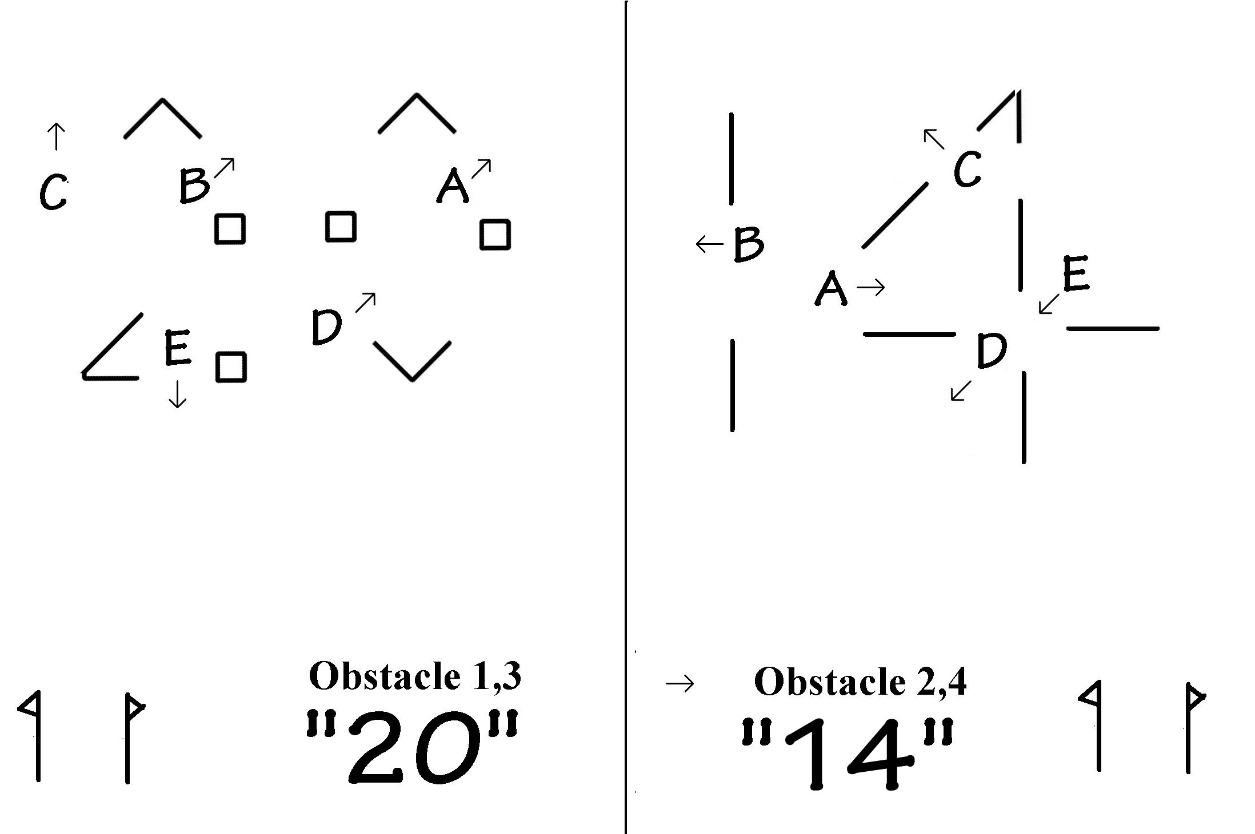
Wix 25th October 2014
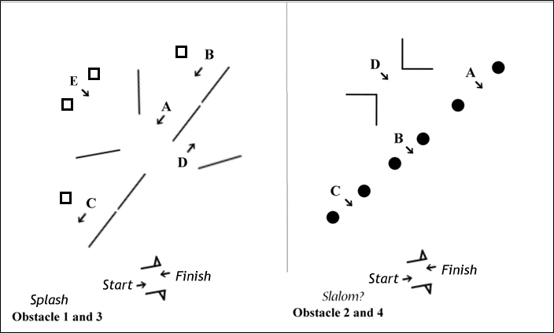

Wix 22nd November 2014 (2/4 – see March 2009, 2007)

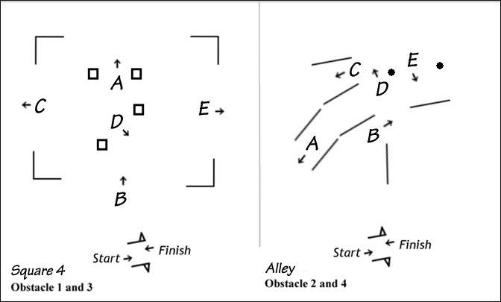

Wix 17 January 2015

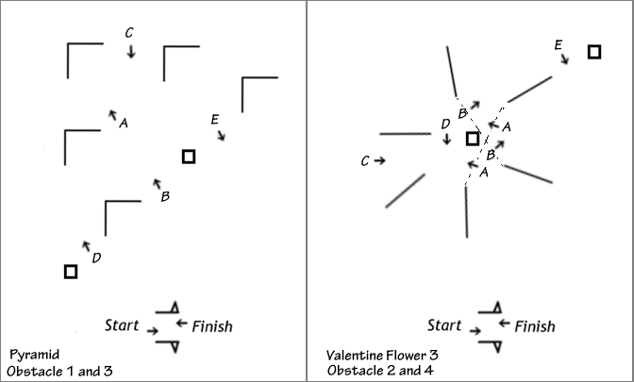
Wix 15 February 2015

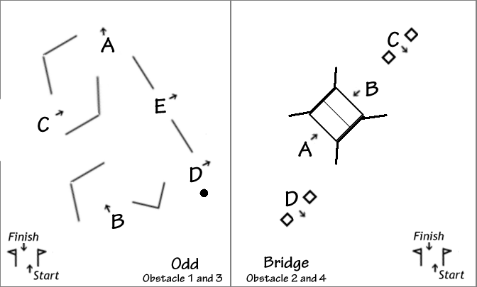
Wix 7 March 2015

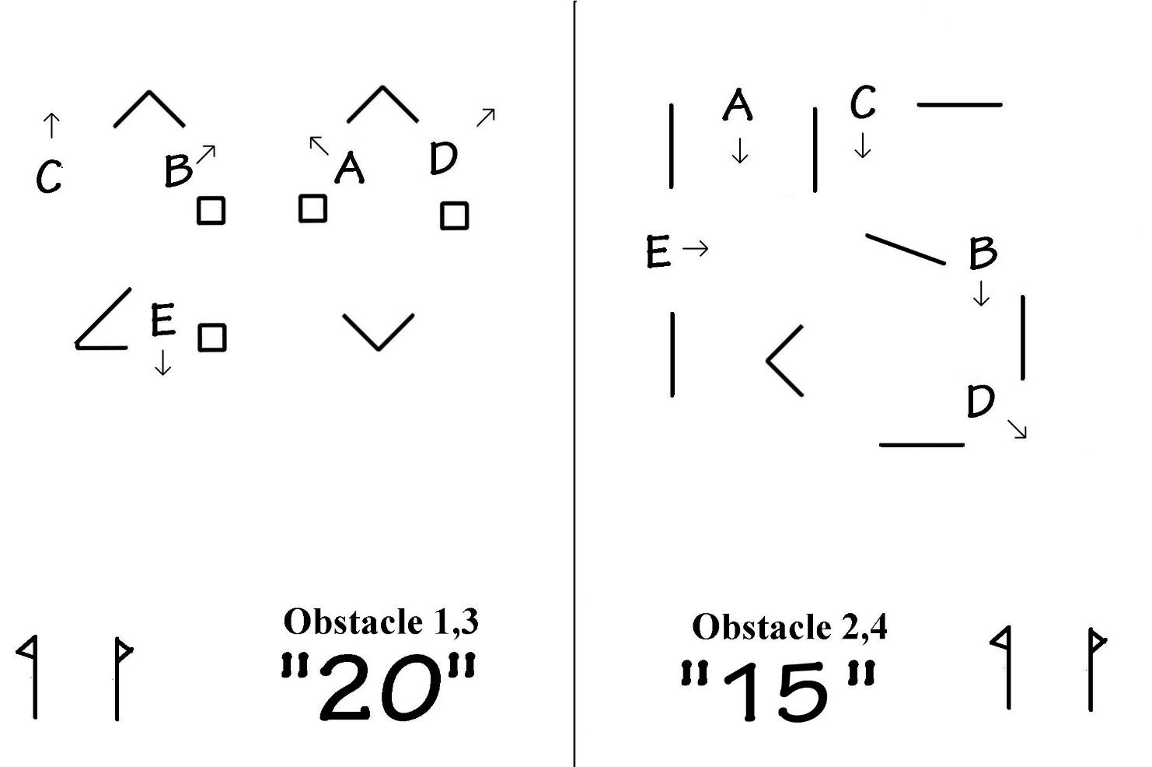
Wix 24 Oct 2015
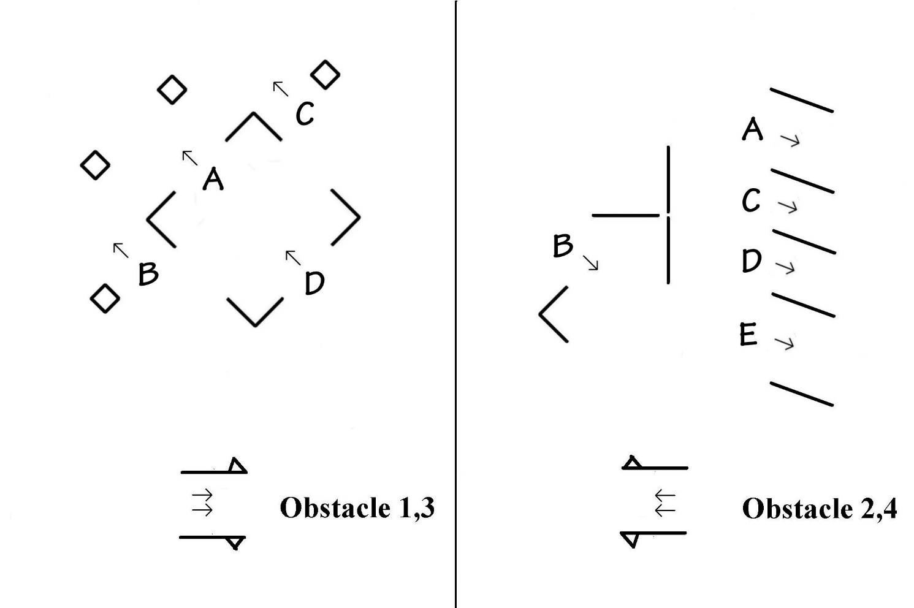
Wix 29 Nov 2015
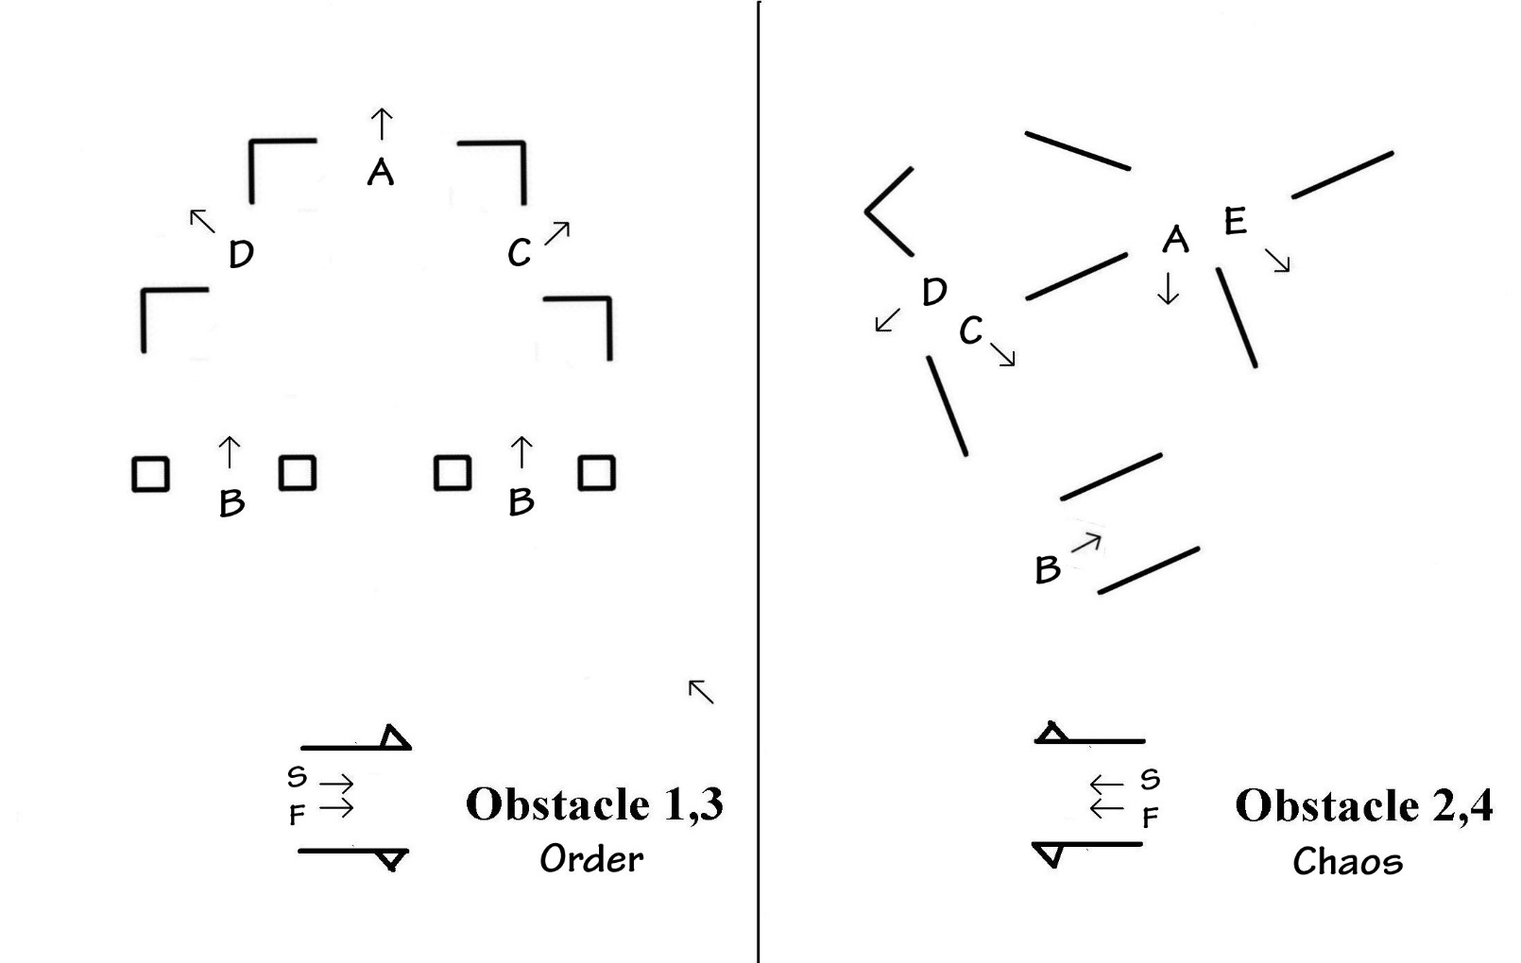
Wix 23 Jan 2016

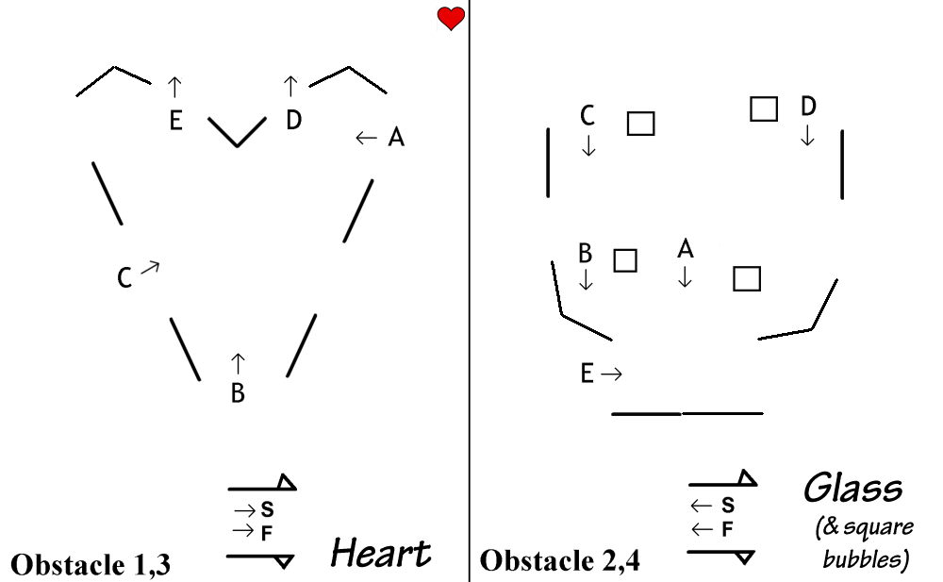
Wix 14 Feb 2016

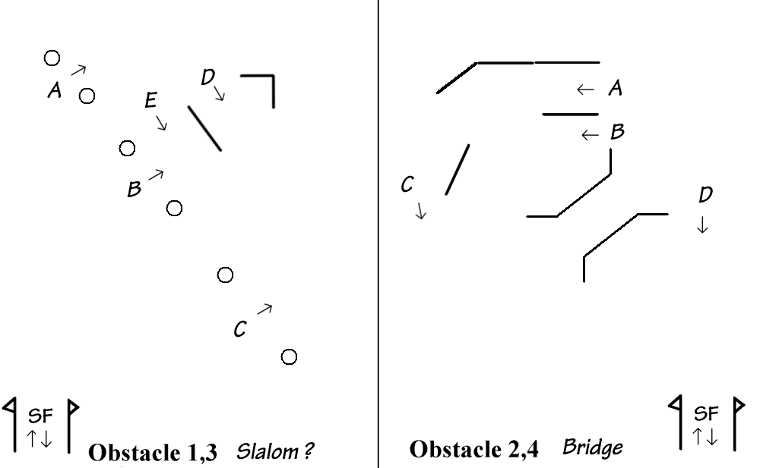
Wix 13 March 2016

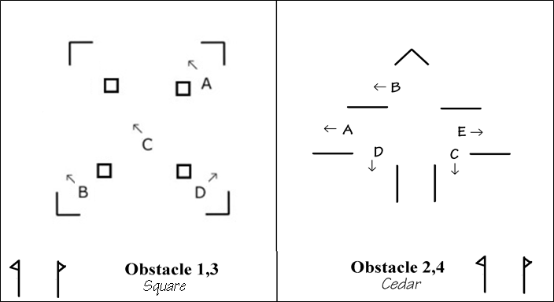
Wix 22 October 2016

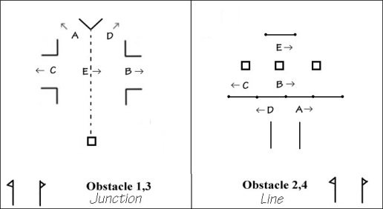
Wix 26 November 2016

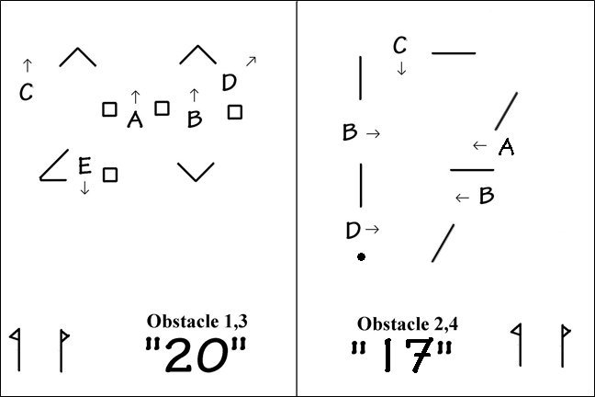Wix 21 January 2017
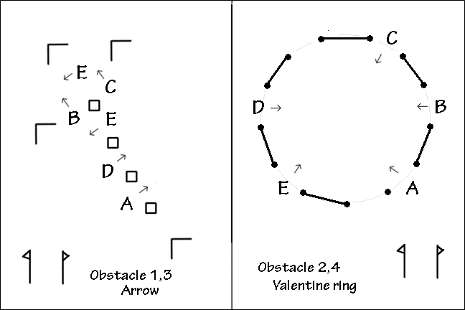
Wix 11 February 2017

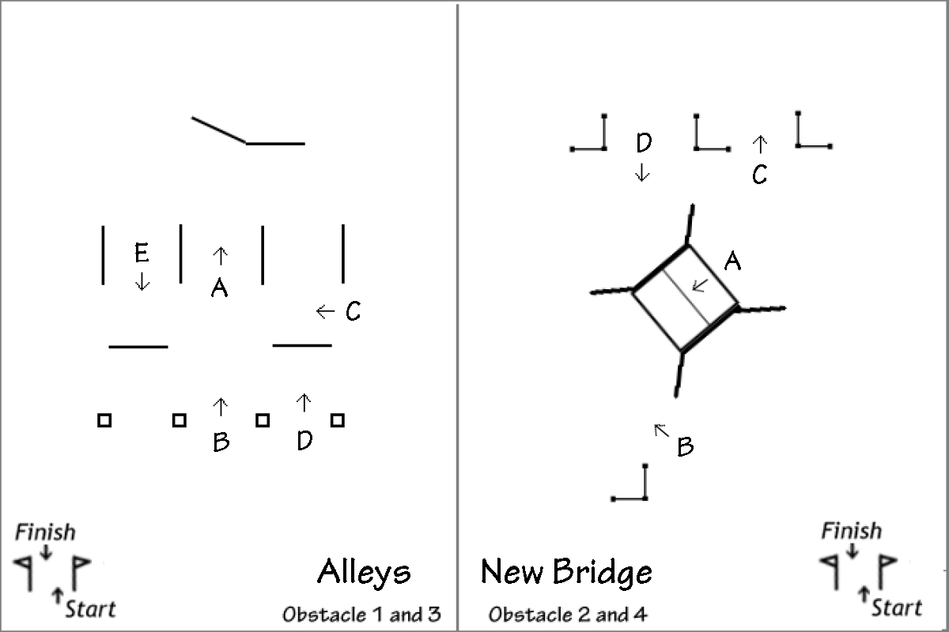
Wix 11 March 2017
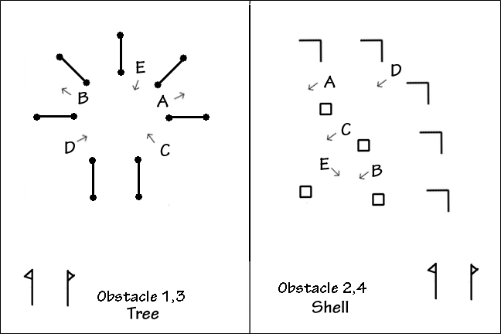
Wix 21 October 2017

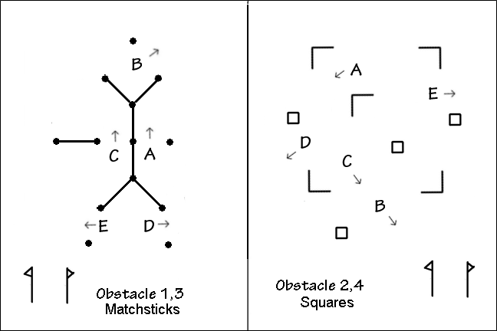
Wix 25 November 2017
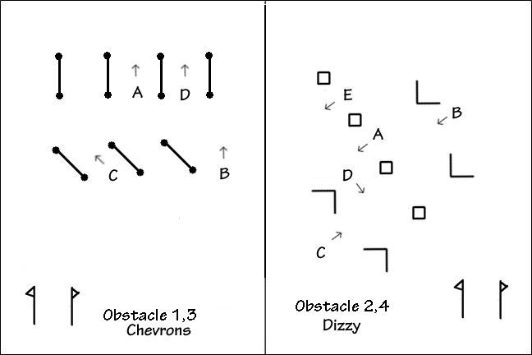
Wix 27 Jan 2018

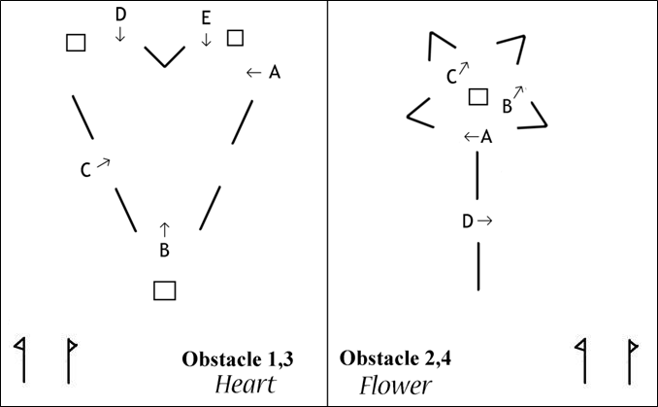
Wix 10 Feb 2018
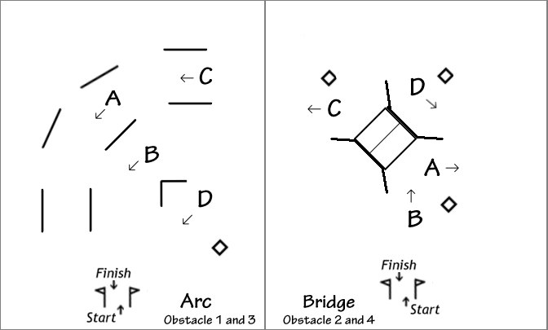
Wix 11 March 2018

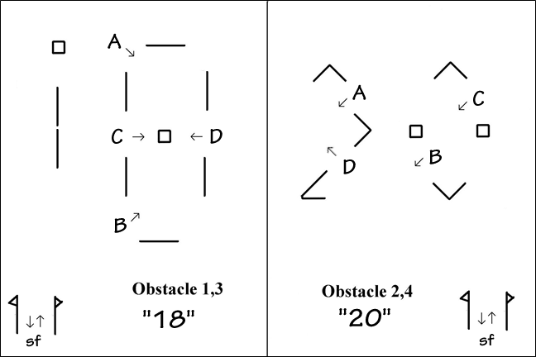
Wix 27 Oct 2018
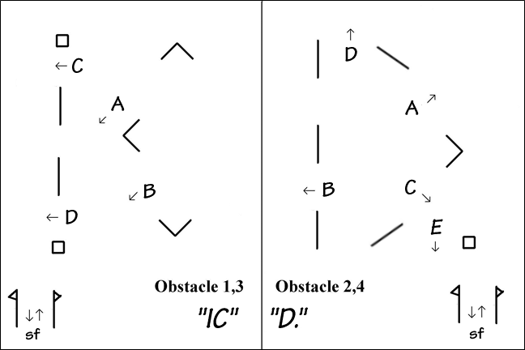
Wix 24 Nov 2018

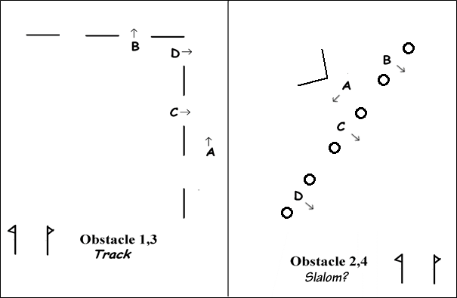
Wix 26 Jan 2019
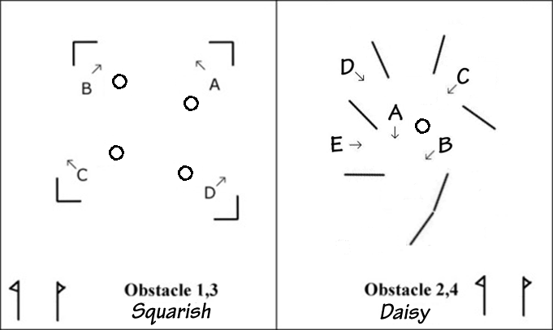
Wix 10 Feb 2019

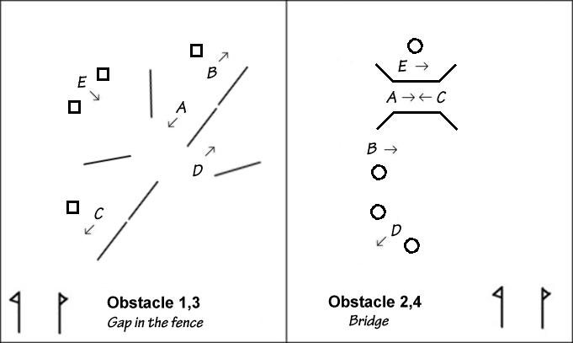
Wix 10 March 2019
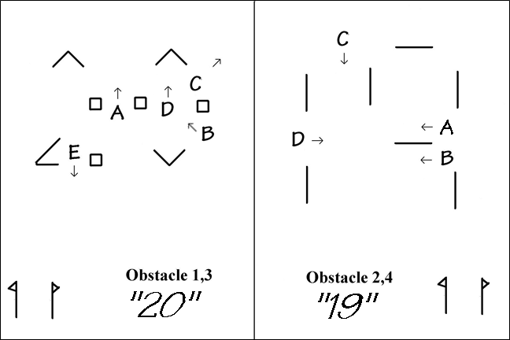
Wix 26 October 2019

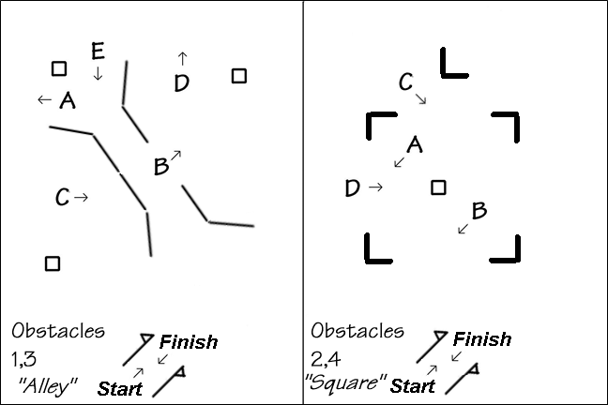
Wix 23 November 2019
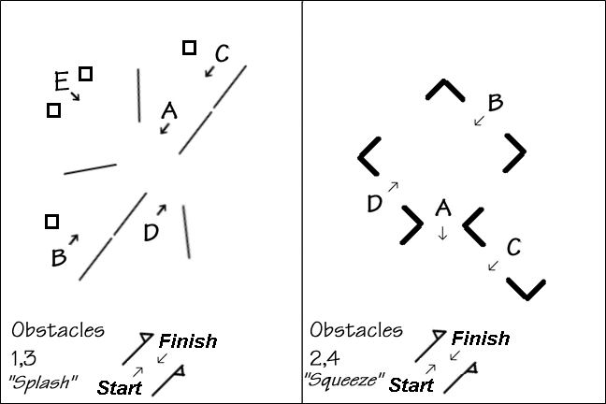
Wix 25 Jan 2020

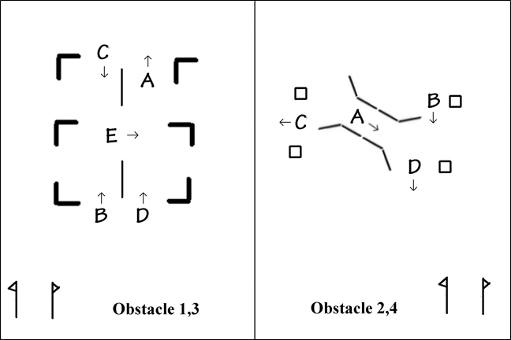
Wix 8 Mar 2020
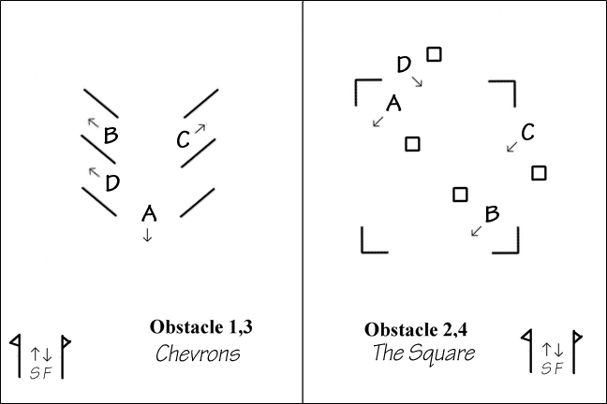
Wix 25 October 2020

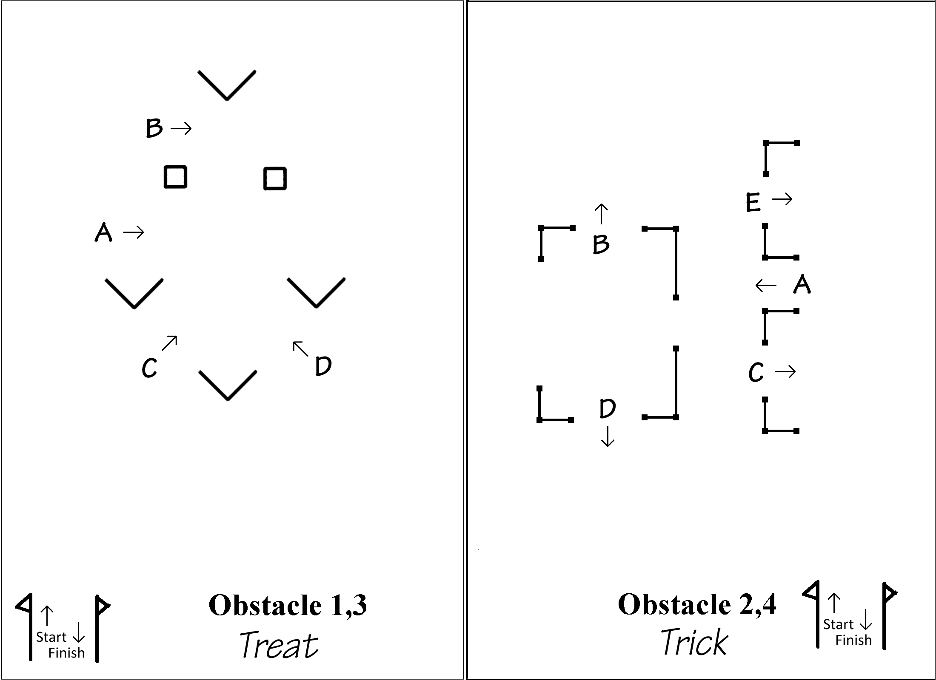
Wix 16 October 2021
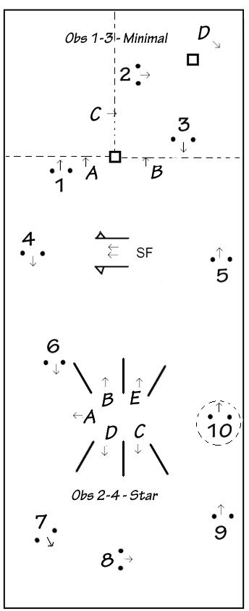 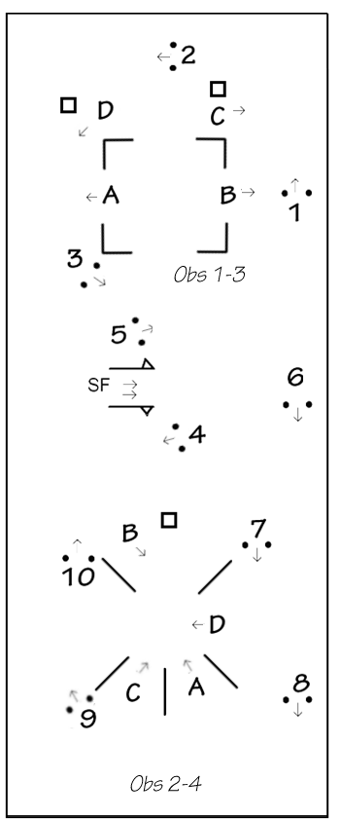
Wix 21 November 2021 Wix 23 January 2022
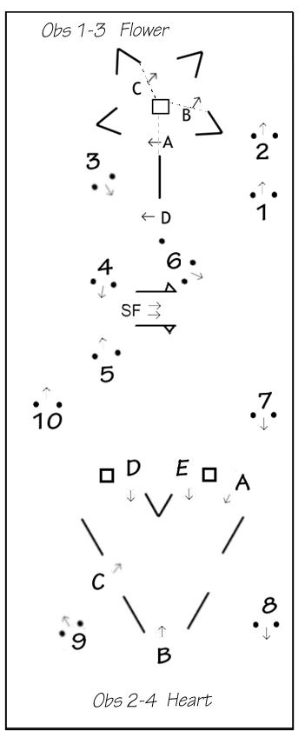

Wix 13 February 2022
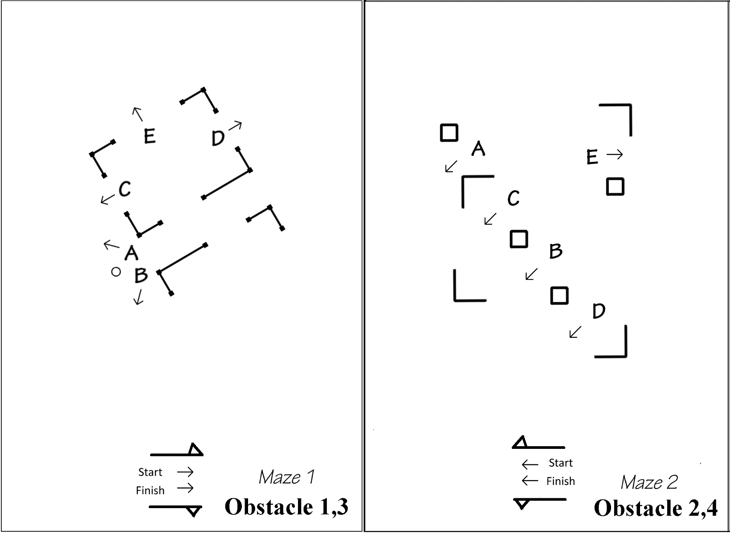
Wix 13 March 2022
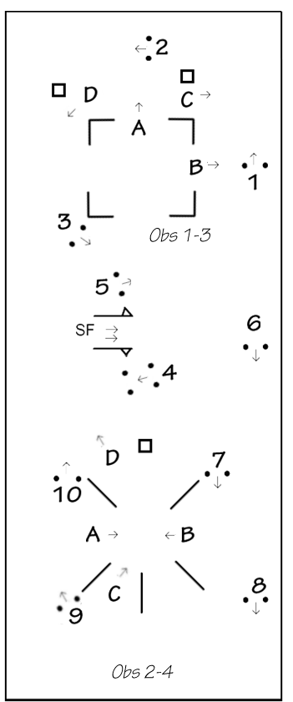 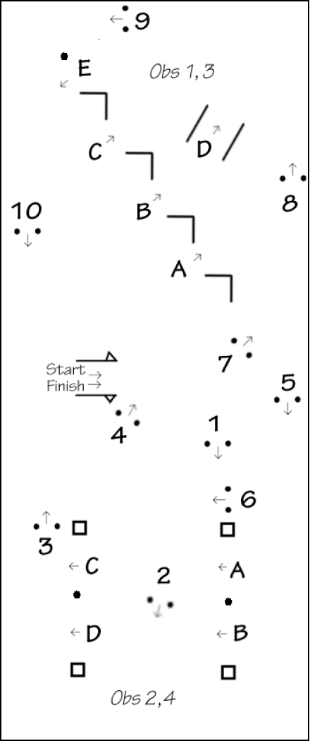

Wix 8 Oct 2022 Wix 20 Nov 2022

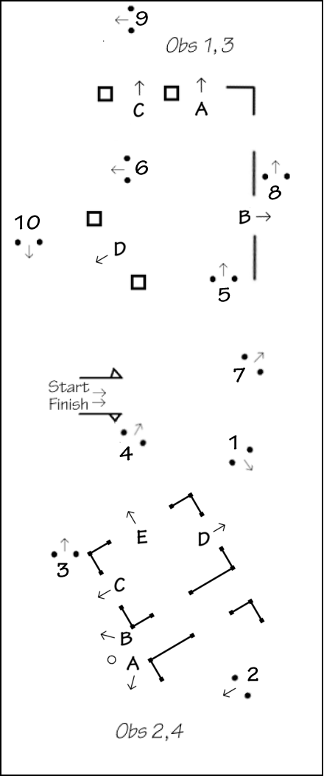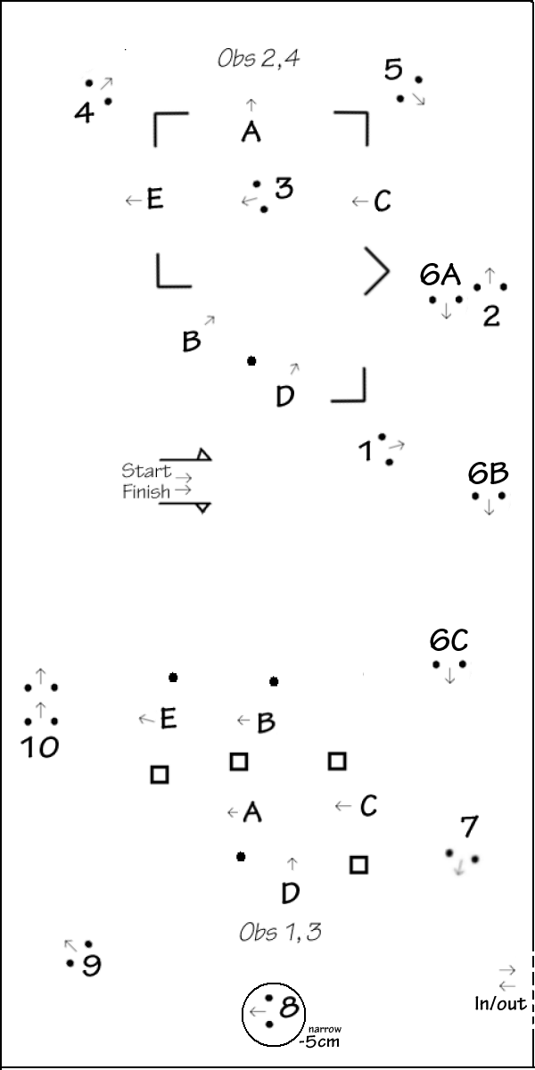

Wix 29 Jan 2023 Beechwood 19 March 2023

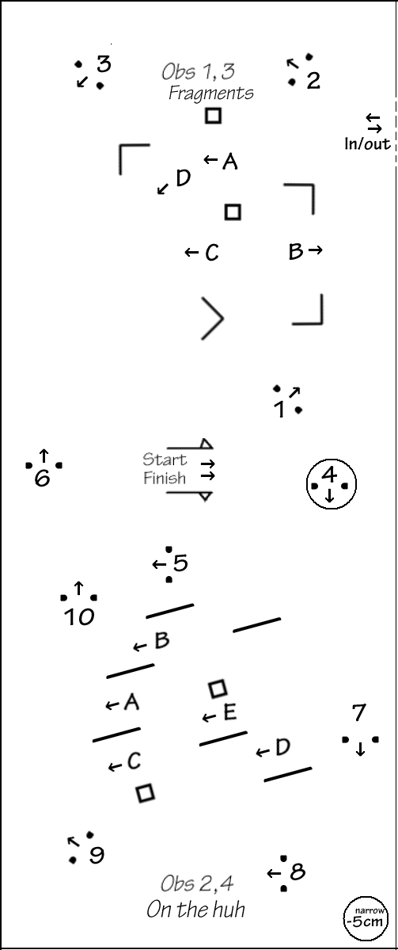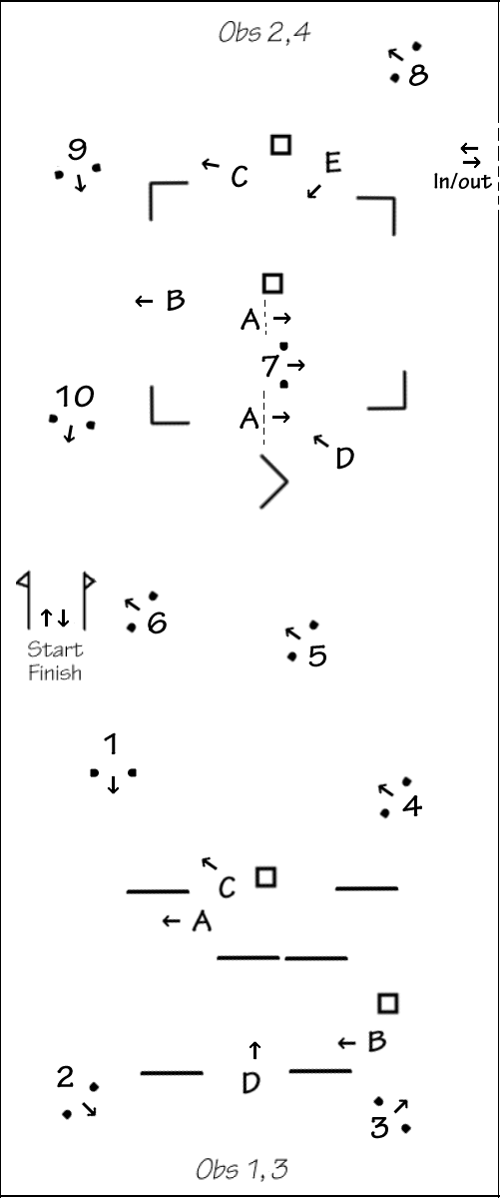

Beechwood 29 October 2023 Beechwood 26 Nov 2023

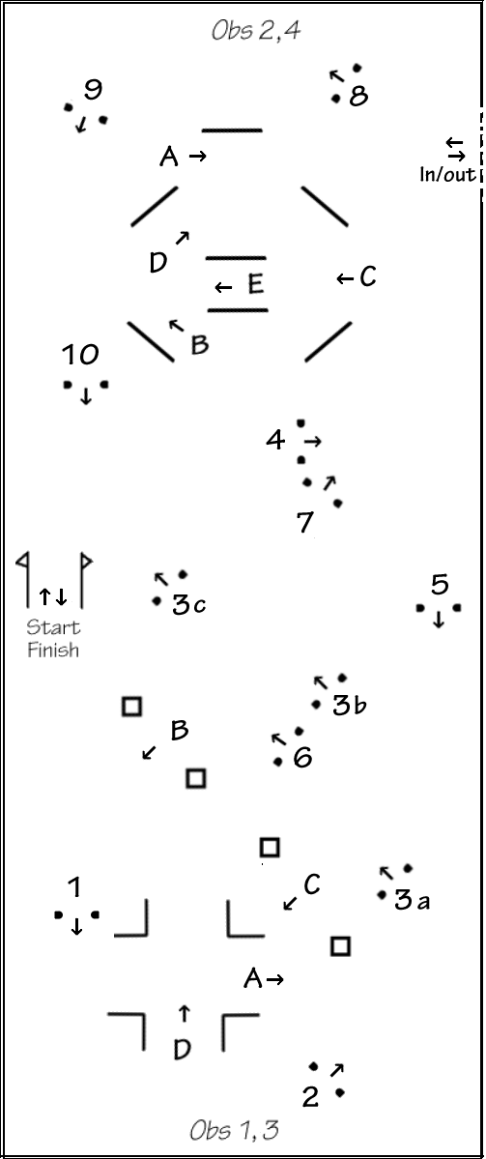

Beechwood 28 Jan 2024

World cup style events:

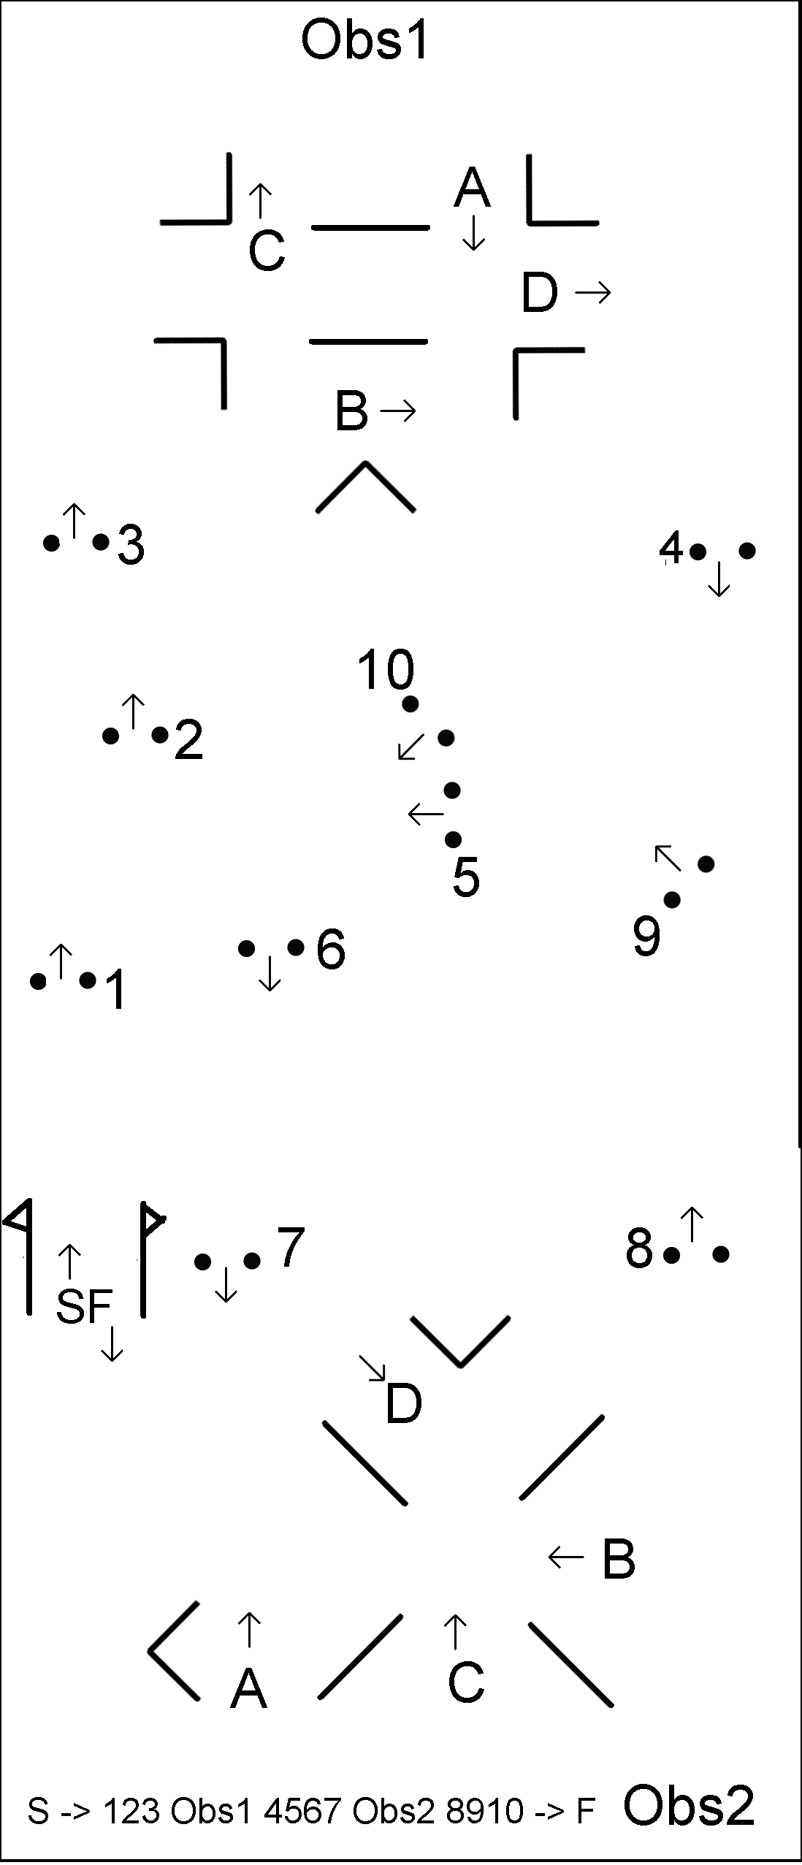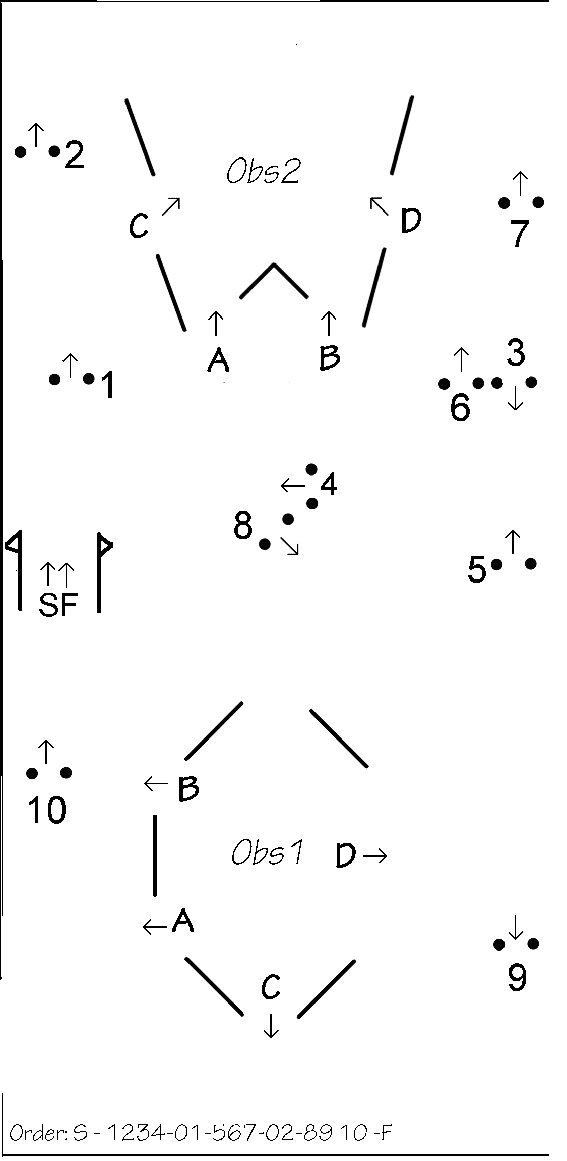

W C
Wix 24 January 2009 Wix 30 December 2009
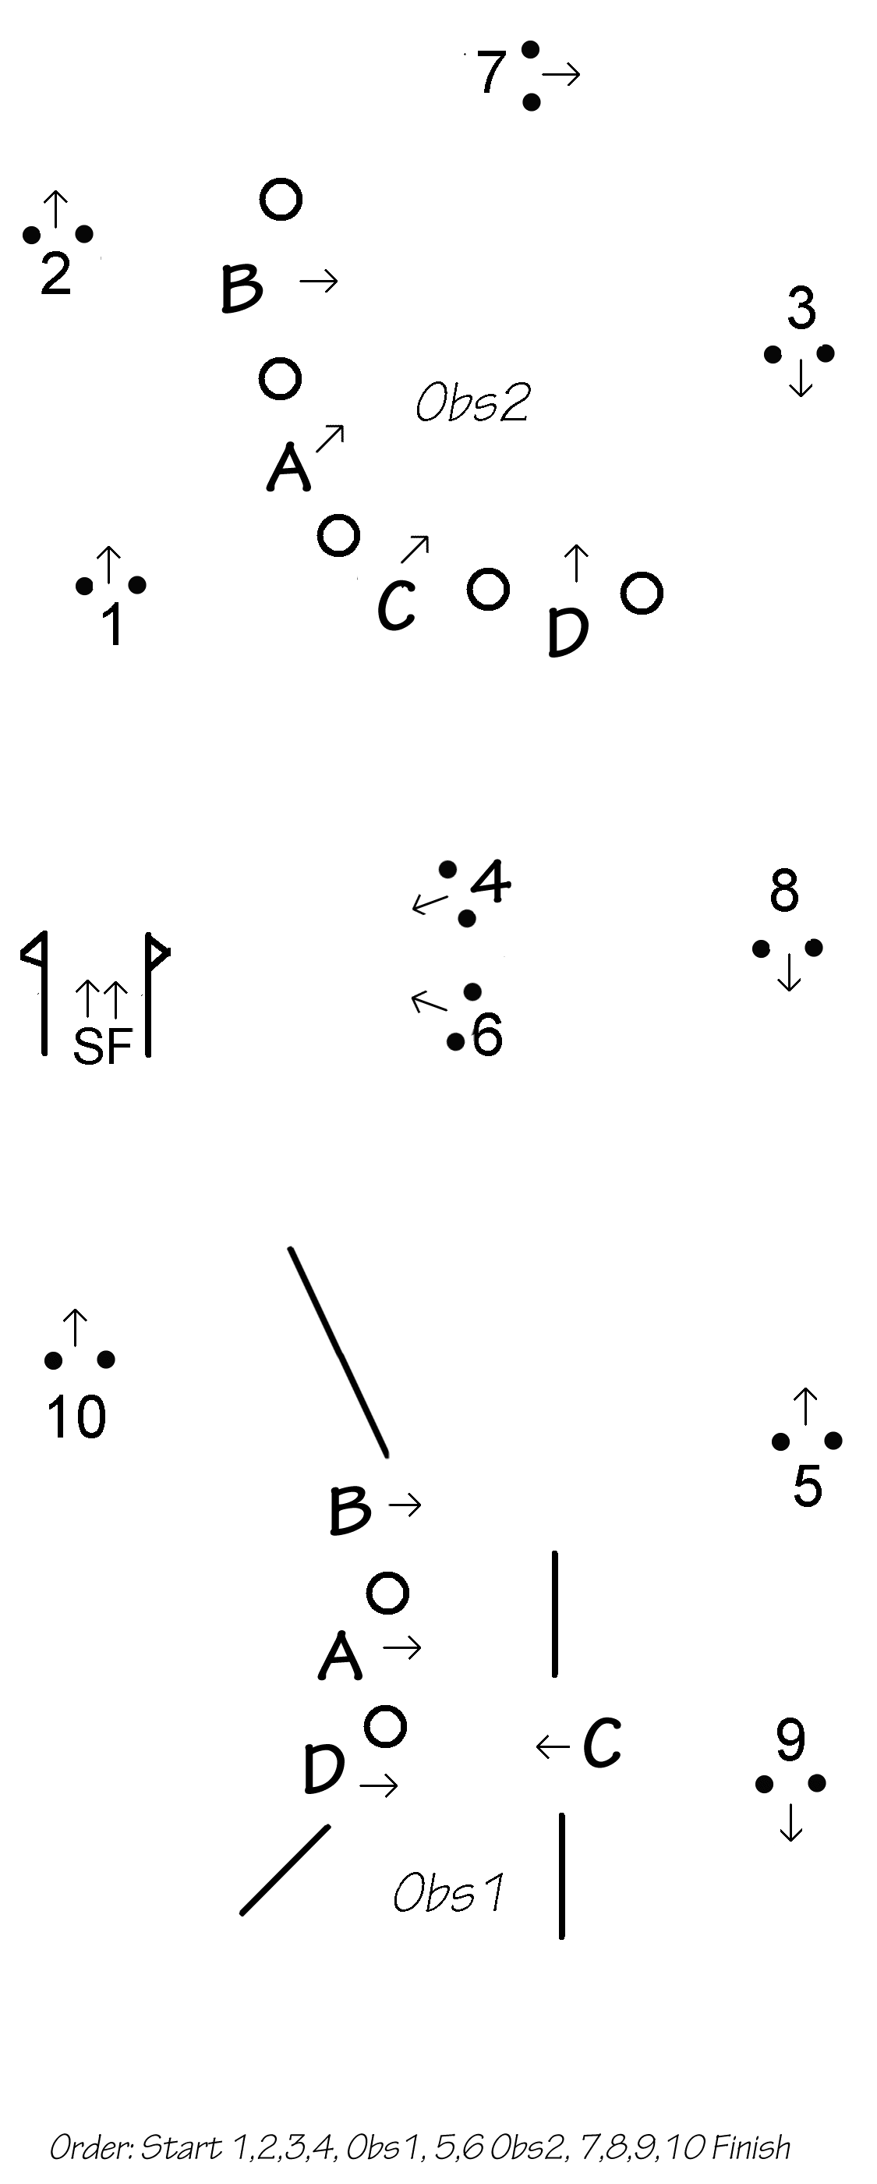
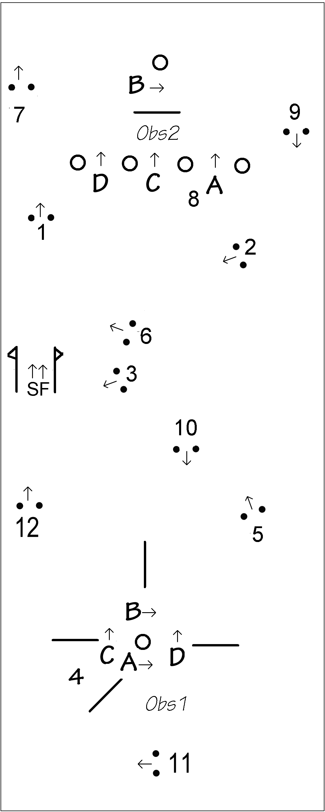
Wix 30 Dec 2010 Wix 31 Dec 2011

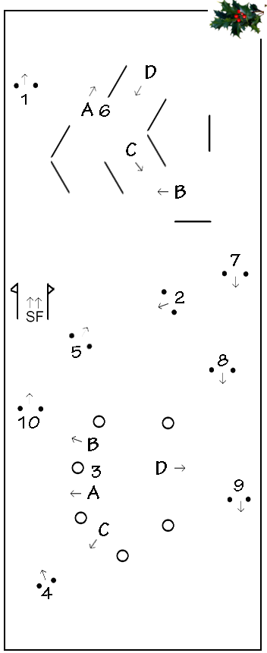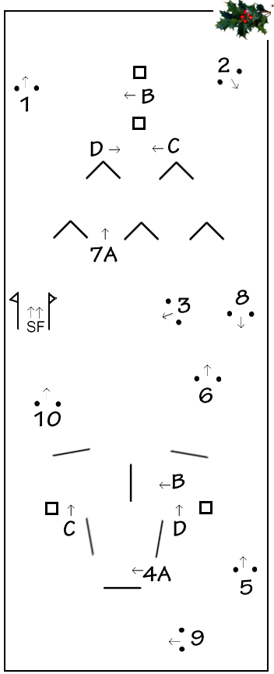

Wix 29 Dec 2012 (cones at 175cm) Wix 29 Dec 2013 (cones at 175cm) Xmas Tree

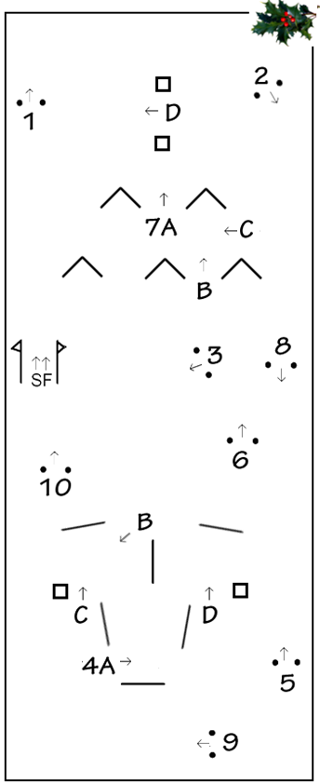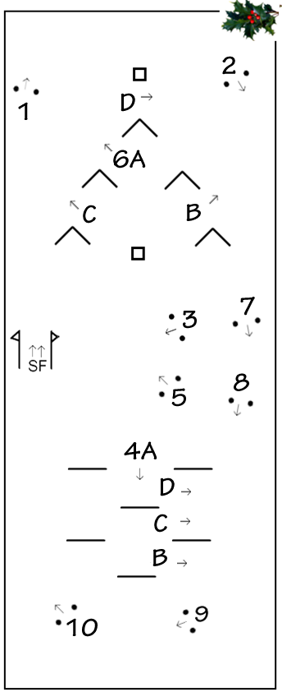

Wix 28 Dec 2014 (cones at 175cm) Wix 30 Dec 2015 (cones at 175cm)

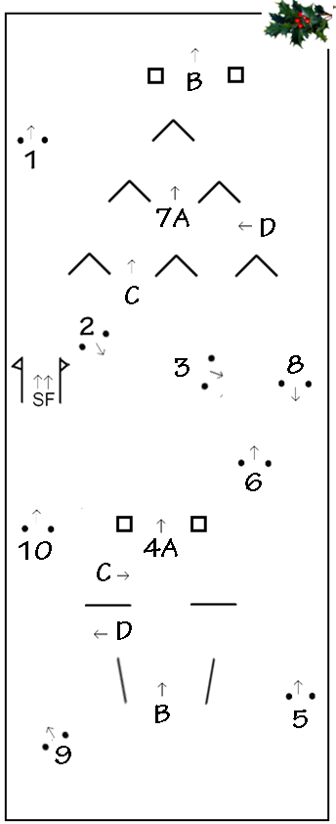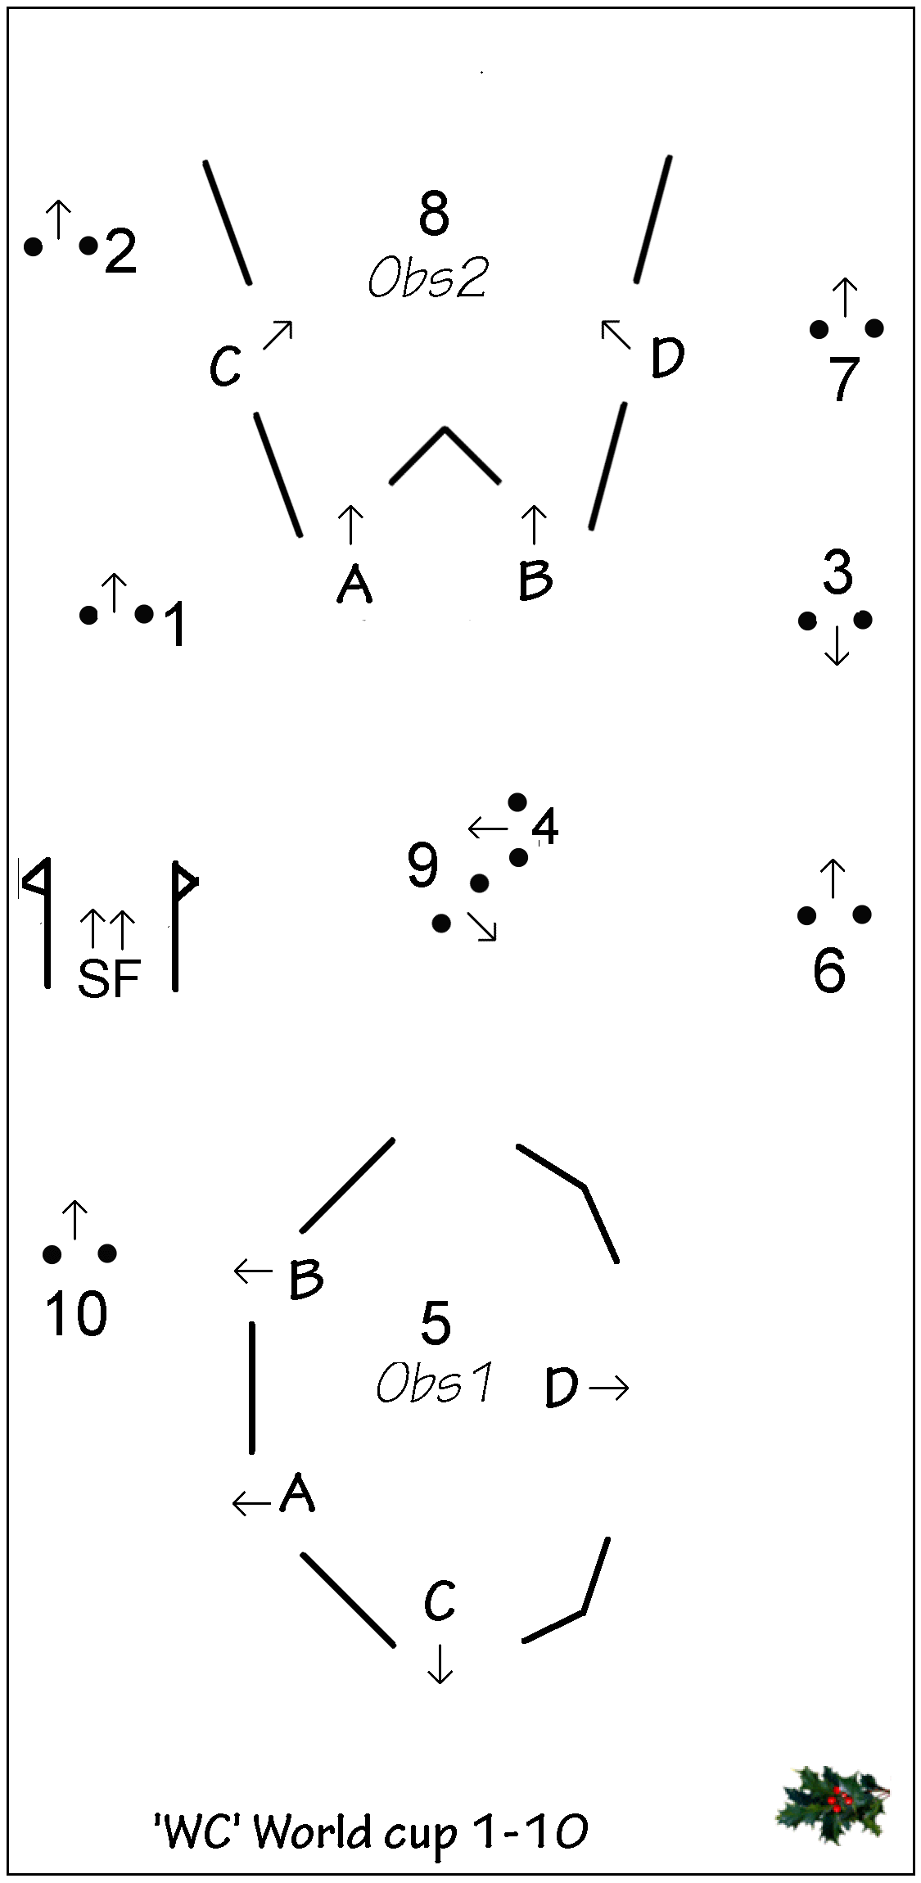

Wix 29 December 2016 (cones at 175cm) Wix 29 December 2017
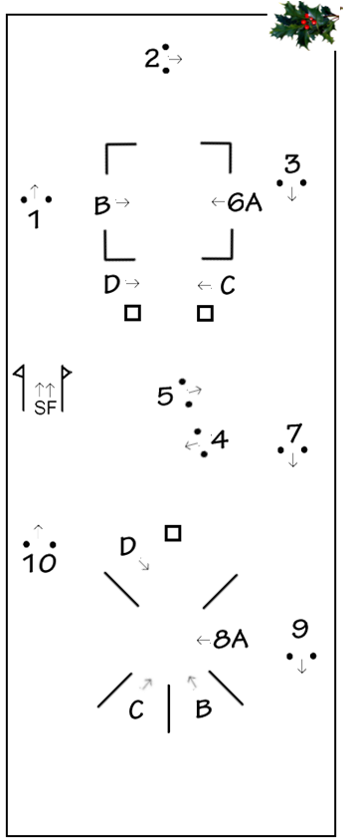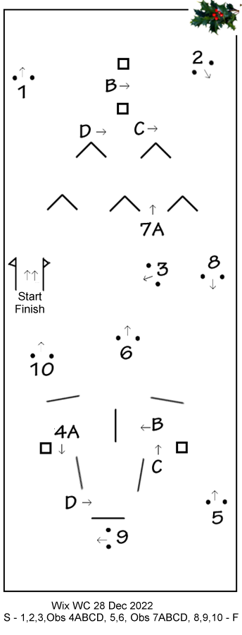
Wix 28 December 2021
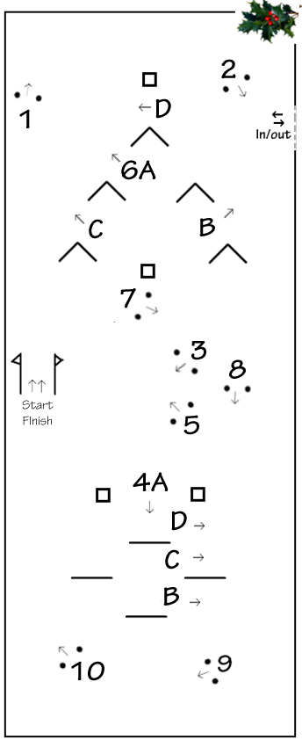

Beechwood 28 Dec 2023

Cones plans

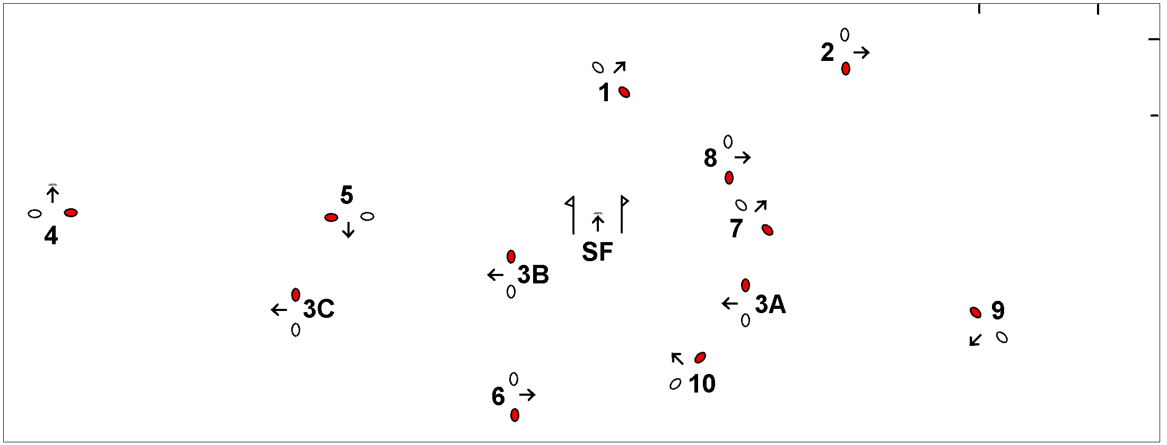
Cones Wix 16th February 2014

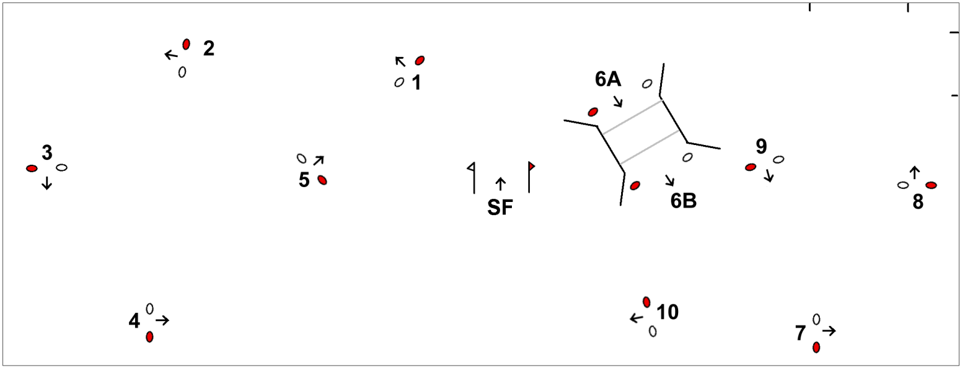
Cones Wix 8th March 2014
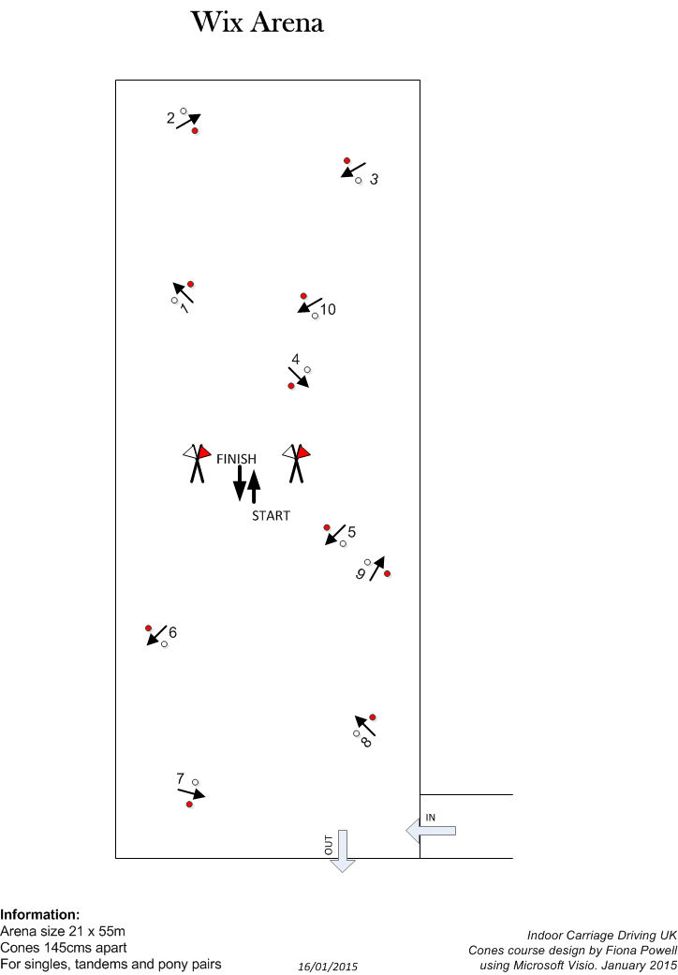
Wix 17 January 2015

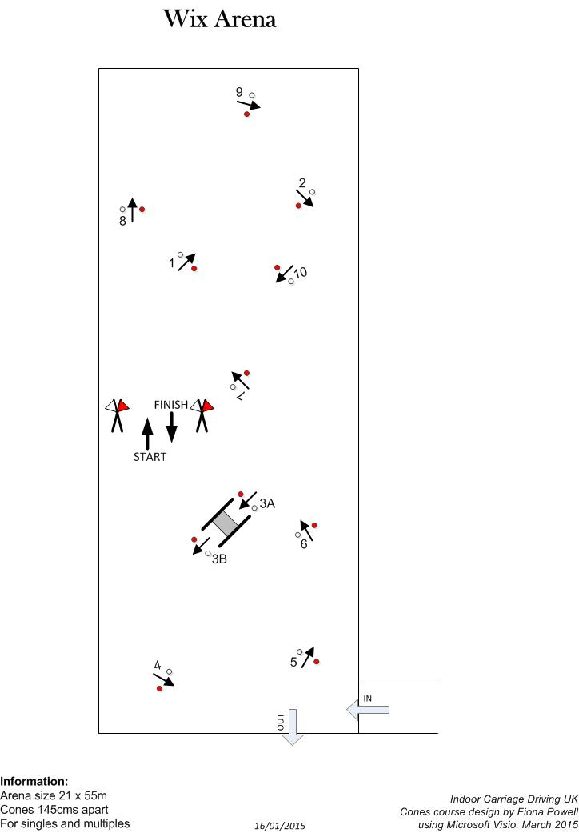
Wix 7 March 2015
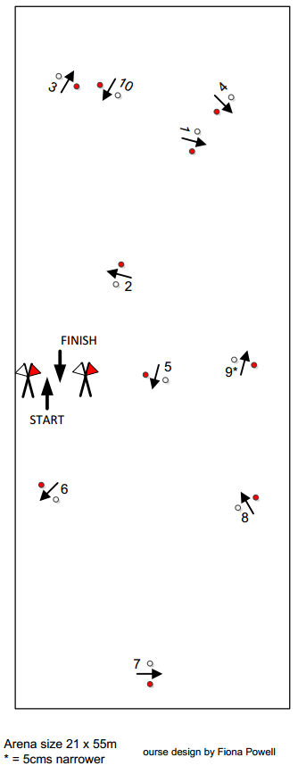
Wix 24 Oct 2015

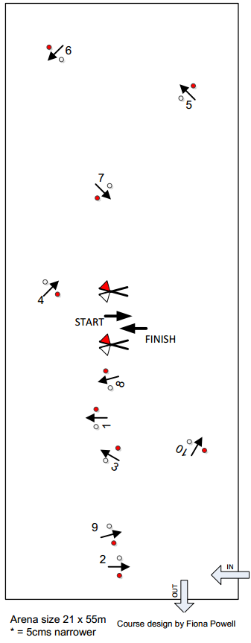

Wix 23 Jan 2016

